UNITED STATES
SECURITIES AND EXCHANGE COMMISSION
Washington, D.C. 20549
FORM 8-K
CURRENT REPORT
Pursuant to Section 13 OR 15(d) of The Securities Exchange Act of 1934

August 5, 2026
Date of Report (date of earliest event reported)

HAGERTY, INC.
(Exact name of registrant as specified in its charter)
Delaware |  |  | 001-40244 |  |  | 86-1213144
(State or other jurisdiction of incorporation or organization) |  |  | (Commission File Number) |  |  | (I.R.S. Employer  Identification No.)

121 Drivers Edge
Traverse City, Michigan 49684
(Address of principal executive offices and zip code)

(800) 922-4050
Registrant's telephone number, including area code

Check the appropriate box below if the Form 8-K filing is intended to simultaneously satisfy the filing obligation of the registrant under any of the following provisions (see General Instruction A.2. below):

☐ Written communications pursuant to Rule 425 under the Securities Act (17 CFR 230.425)

☐ Soliciting material pursuant to Rule 14a-12 under the Exchange Act (17 CFR 240.14a-12)

☐ Pre-commencement communications pursuant to Rule 14d-2(b) under the Exchange Act (17 CFR 240.14d-2(b))

☐ Pre-commencement communications pursuant to Rule 13e-4(c) under the Exchange Act (17 CFR 240.13e-4(c))

Securities registered pursuant to Section 12(b) of the Act:
Title of each class |  |  |  |  |  | Trading Symbols |  |  |  |  |  | Name of each exchange on which registered
Class A common stock, par value $0.0001 per share |  |  |  |  |  | HGTY |  |  |  |  |  | The New York Stock Exchange

Indicate by check mark whether the registrant is an emerging growth company as defined in Rule 405 of the Securities Act of 1933 (§230.405 of this chapter) or Rule 12b-2 of the Securities Exchange Act of 1934 (§240.12b-2 of this chapter).
Emerging growth company ☐

If an emerging growth company, indicate by check mark if the registrant has elected not to use the extended transition period for complying with any new or revised financial accounting standards provided pursuant to Section 13(a) of the Exchange Act. ☐

ITEM 2.02 Results of Operations and Financial Condition

On August 5, 2026, Hagerty, Inc. (the "Company") announced its financial results for the fiscal quarter ended June 30, 2026 by issuing a letter to its stockholders and a press release. The Company will also be holding a conference call on August 5, 2026 to discuss its financial results for the three and six months ended June 30, 2026. The full text of the Company's letter to its stockholders and press release are attached hereto as Exhibit 99.1 and Exhibit 99.2, respectively.

ITEM 7.01 Regulation FD Disclosure

On August 5, 2026, the Company posted to the investor relations page of its website an investor presentation expected to be used by the Company in connection with certain future presentations to investors and others. A copy of the investor presentation is attached as Exhibit 99.3 to this Current Report on Form 8-K.

The Company uses its investor relations website as a means of disclosing material non-public information, announcing upcoming investor conferences and for complying with its disclosure obligations under Regulation FD. Accordingly, investors should monitor the Company's investor relations website in addition to following its press releases, SEC filings and public conference calls and webcasts.

The information contained in Item 2.02 and Item 7.01 of this Current Report on Form 8-K, including Exhibits 99.1, 99.2 and 99.3, shall not be deemed to be "filed" for the purposes of Section 18 of the Securities Exchange Act of 1934, as amended (the "Exchange Act") or otherwise subject to the liabilities of that section, nor shall it be incorporated by reference into a filing under the Securities Act of 1933, as amended, or the Exchange Act, except as shall be expressly set forth by specific reference in such a filing.

Item 9.01 Financial Statements and Exhibits

(d) Exhibits

Exhibit No. |  |  |  |  |  | Description
99.1 |  |  |  |  |  | Letter to Stockholders, dated August 5, 2026
99.2 |  |  |  |  |  | Press Release, dated August 5, 2026
99.3 |  |  |  |  |  | Investor Presentation, dated August 5, 2026
104 |  |  |  |  |  | Cover Page Interactive Data File (formatted as Inline XBRL)

SIGNATURES
Pursuant to the requirements of the Securities Exchange Act of 1934, the Registrant has duly caused this report to be signed on its behalf by the undersigned hereunto duly authorized.

 |  |  |  |  |  | HAGERTY, INC.
 |  |  |  |  |  | /s/ Diana M. Chafey
Date: August 5, 2026 |  |  |  |  |  | Diana M. Chafey
 |  |  |  |  |  | Chief Legal Officer


STOCKHOLDER LETTER Q2 2026

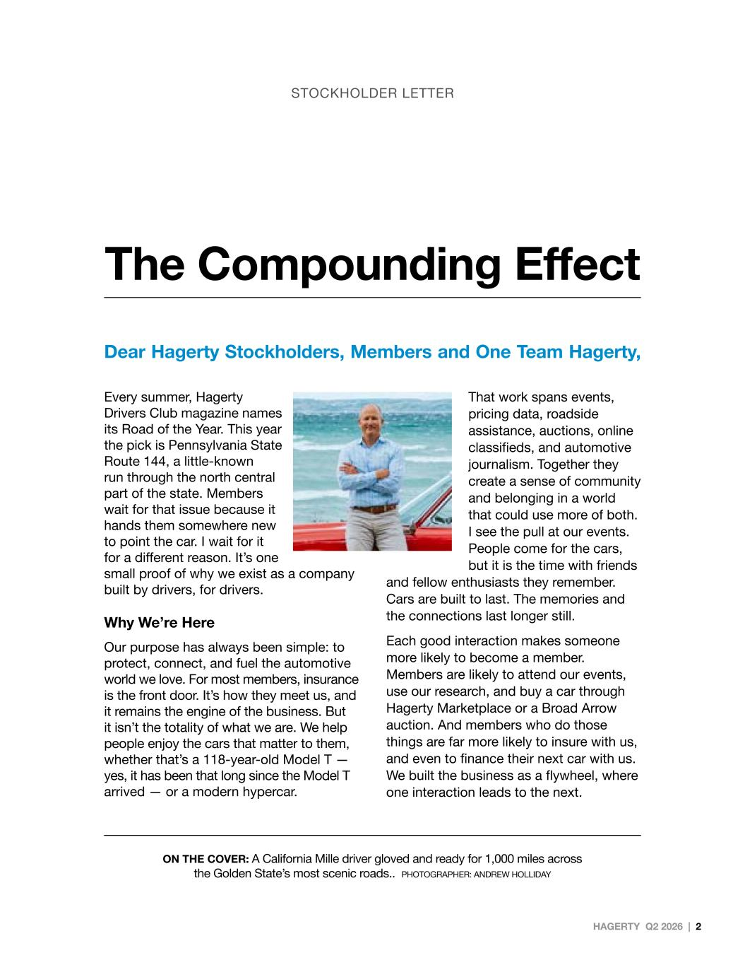
Every summer, Hagerty Drivers Club magazine names its Road of the Year. This year the pick is Pennsylvania State Route 144, a little-known run through the north central part of the state. Members wait for that issue because it hands them somewhere new to point the car. I wait for it for a different reason. It’s one small proof of why we exist as a company built by drivers, for drivers. Why We’re Here Our purpose has always been simple: to protect, connect, and fuel the automotive world we love. For most members, insurance is the front door. It’s how they meet us, and it remains the engine of the business. But it isn’t the totality of what we are. We help people enjoy the cars that matter to them, whether that’s a 118-year-old Model T — yes, it has been that long since the Model T arrived — or a modern hypercar. That work spans events, pricing data, roadside assistance, auctions, online classifieds, and automotive journalism. Together they create a sense of community and belonging in a world that could use more of both. I see the pull at our events. People come for the cars, but it is the time with friends and fellow enthusiasts they remember. Cars are built to last. The memories and the connections last longer still. Each good interaction makes someone more likely to become a member. Members are likely to attend our events, use our research, and buy a car through Hagerty Marketplace or a Broad Arrow auction. And members who do those things are far more likely to insure with us, and even to finance their next car with us. We built the business as a flywheel, where one interaction leads to the next. Dear Hagerty Stockholders, Members and One Team Hagerty, STOCKHOLDER LETTER The Compounding Effect ON THE COVER: A California Mille driver gloved and ready for 1,000 miles across the Golden State’s most scenic roads.. PHOTOGRAPHER: ANDREW HOLLIDAY HAGERTY Q2 2026 | 2

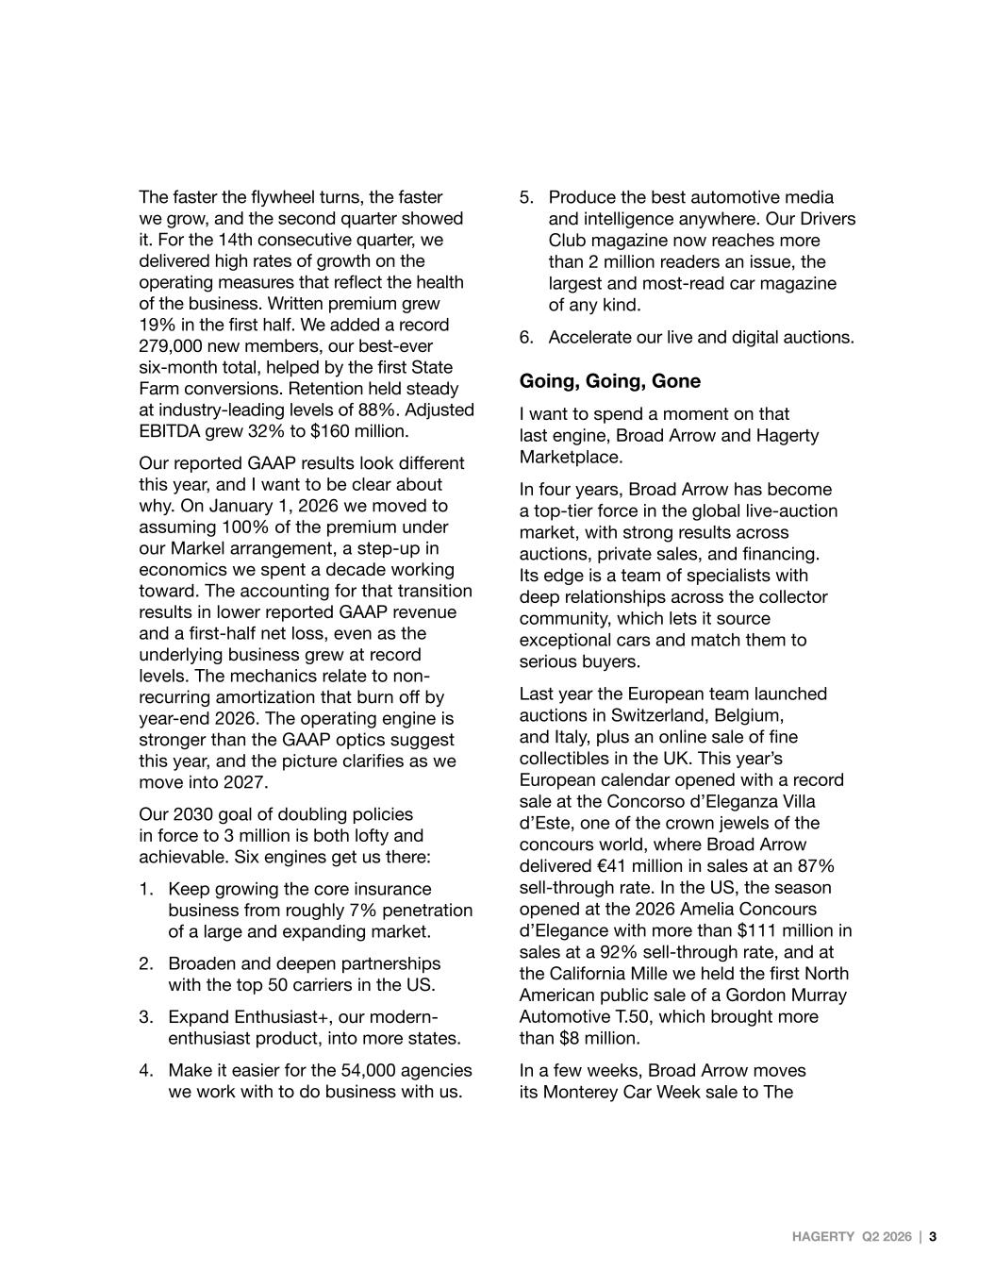
HAGERTY Q2 2026 | 3 The faster the flywheel turns, the faster we grow, and the second quarter showed it. For the 14th consecutive quarter, we delivered high rates of growth on the operating measures that reflect the health of the business. Written premium grew 19% in the first half. We added a record 279,000 new members, our best-ever six-month total, helped by the first State Farm conversions. Retention held steady at industry-leading levels of 88%. Adjusted EBITDA grew 32% to $160 million. Our reported GAAP results look different this year, and I want to be clear about why. On January 1, 2026 we moved to assuming 100% of the premium under our Markel arrangement, a step-up in economics we spent a decade working toward. The accounting for that transition results in lower reported GAAP revenue and a first-half net loss, even as the underlying business grew at record levels. The mechanics relate to non- recurring amortization that burn off by year-end 2026. The operating engine is stronger than the GAAP optics suggest this year, and the picture clarifies as we move into 2027. Our 2030 goal of doubling policies in force to 3 million is both lofty and achievable. Six engines get us there: 1. Keep growing the core insurance business from roughly 7% penetration of a large and expanding market. 2. Broaden and deepen partnerships with the top 50 carriers in the US. 3. Expand Enthusiast+, our modern- enthusiast product, into more states. 4. Make it easier for the 54,000 agencies we work with to do business with us. 5. Produce the best automotive media and intelligence anywhere. Our Drivers Club magazine now reaches more than 2 million readers an issue, the largest and most-read car magazine of any kind. 6. Accelerate our live and digital auctions. Going, Going, Gone I want to spend a moment on that last engine, Broad Arrow and Hagerty Marketplace. In four years, Broad Arrow has become a top-tier force in the global live-auction market, with strong results across auctions, private sales, and financing. Its edge is a team of specialists with deep relationships across the collector community, which lets it source exceptional cars and match them to serious buyers. Last year the European team launched auctions in Switzerland, Belgium, and Italy, plus an online sale of fine collectibles in the UK. This year’s European calendar opened with a record sale at the Concorso d’Eleganza Villa d’Este, one of the crown jewels of the concours world, where Broad Arrow delivered €41 million in sales at an 87% sell-through rate. In the US, the season opened at the 2026 Amelia Concours d’Elegance with more than $111 million in sales at a 92% sell-through rate, and at the California Mille we held the first North American public sale of a Gordon Murray Automotive T.50, which brought more than $8 million. In a few weeks, Broad Arrow moves its Monterey Car Week sale to The

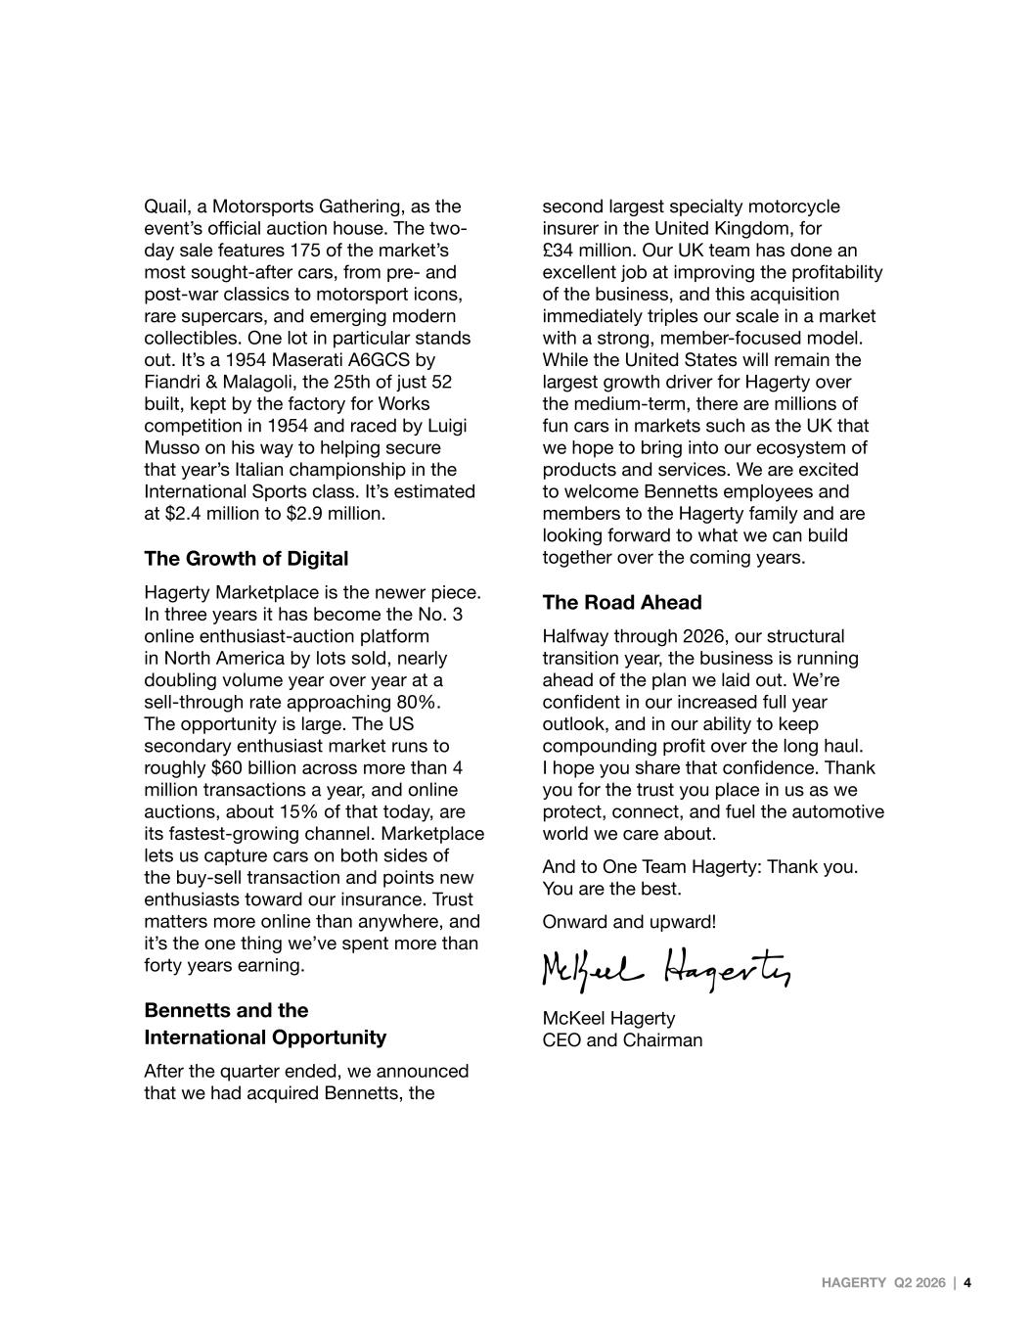
Quail, a Motorsports Gathering, as the event’s official auction house. The two- day sale features 175 of the market’s most sought-after cars, from pre- and post-war classics to motorsport icons, rare supercars, and emerging modern collectibles. One lot in particular stands out. It’s a 1954 Maserati A6GCS by Fiandri & Malagoli, the 25th of just 52 built, kept by the factory for Works competition in 1954 and raced by Luigi Musso on his way to helping secure that year’s Italian championship in the International Sports class. It’s estimated at $2.4 million to $2.9 million. The Growth of Digital Hagerty Marketplace is the newer piece. In three years it has become the No. 3 online enthusiast-auction platform in North America by lots sold, nearly doubling volume year over year at a sell-through rate approaching 80%. The opportunity is large. The US secondary enthusiast market runs to roughly $60 billion across more than 4 million transactions a year, and online auctions, about 15% of that today, are its fastest-growing channel. Marketplace lets us capture cars on both sides of the buy-sell transaction and points new enthusiasts toward our insurance. Trust matters more online than anywhere, and it’s the one thing we’ve spent more than forty years earning. Bennetts and the International Opportunity After the quarter ended, we announced that we had acquired Bennetts, the second largest specialty motorcycle insurer in the United Kingdom, for £34 million. Our UK team has done an excellent job at improving the profitability of the business, and this acquisition immediately triples our scale in a market with a strong, member-focused model. While the United States will remain the largest growth driver for Hagerty over the medium-term, there are millions of fun cars in markets such as the UK that we hope to bring into our ecosystem of products and services. We are excited to welcome Bennetts employees and members to the Hagerty family and are looking forward to what we can build together over the coming years. The Road Ahead Halfway through 2026, our structural transition year, the business is running ahead of the plan we laid out. We’re confident in our increased full year outlook, and in our ability to keep compounding profit over the long haul. I hope you share that confidence. Thank you for the trust you place in us as we protect, connect, and fuel the automotive world we care about. And to One Team Hagerty: Thank you. You are the best. Onward and upward! McKeel Hagerty CEO and Chairman HAGERTY Q2 2026 | 4



For Immediate Release

Hagerty Reports Second Quarter 2026 Results
Increases 2026 Growth Outlook

First Half 2026 Highlights:
•Strong underlying operational performance with record growth in members, written premium, and earned premium
•First half 2026 Written Premium grew 19% year-over-year to $713 million
•Added a record 279,000 new members in the first half of 2026, with policy in force growth of 19% year-over-year to 1.9 million members
•First half 2026 Earned Premium increased 42% to $492 million
•Transition to Markel Fronting Arrangement on January 1, 2026 resulted in decrease to reported revenue as previously disclosed
•First half 2026 Net Loss of $5 million, including $153 million of pre-tax Markel Fronting Arrangement transitional costs, compared to Net Income of $74 million in the prior year period
•First half 2026 Adjusted EBITDA (a non-GAAP measure) increased 32% to $160 million, compared to $121 million in the prior year period
•First half 2026 Cash Flow from Operating Activities increased 91% to $186 million
•Increased 2026 Outlook — Written Premium growth of 16% to 17%, Net Income of $18 to $30 million, and Adjusted EBITDA of $270 to $280 million

TRAVERSE CITY, MI, August 5, 2026 /PRNewswire/ – Hagerty, Inc. (NYSE: HGTY) makes it easier and more enjoyable for car enthusiasts to drive and celebrate the vehicles they love — through specialty vehicle insurance, live and digital auctions, engaging media and events, and the Hagerty Drivers Club, the world's largest membership community of car lovers. Today the company announced financial results for the three and six months ended June 30, 2026.

"The first half of 2026 has been the best in Hagerty's history, and our results give us the confidence to significantly increase our full year outlook. We delivered year-to-date written premium growth of 19% and Adjusted EBITDA gains of 32%, reflecting the compounding power of our model as we now control 100% of the economics on our U.S. book. This is what forty years of building trust — one member, one partner, one car at a time — looks like when the flywheel hits its stride," said McKeel Hagerty, Chief Executive Officer and Chairman of Hagerty.

“Our momentum is showing up across every part of the Hagerty ecosystem, including crossing three million insured vehicles. Broad Arrow delivered first half revenue growth of 17%, with a 91% auction sell-through rate and demand from buyers on multiple continents. And in the third quarter, we will welcome the team and members of Bennetts, the United Kingdom's second largest specialty motorcycle insurance broker to the Hagerty family, tripling our scale in that market," added Mr. Hagerty.

1
SECOND QUARTER 2026 FINANCIAL HIGHLIGHTS

•Second quarter 2026 Written Premium increased 19% year-over-year to $425 million, and year-to-date 2026 Written Premium increased 19% year-over-year to $713 million
•Second quarter 2026 Hagerty Re Earned Premium increased 42% year-over-year to $252 million, and year-to-date 2026 Earned Premium increased 42% year-over-year to $492 million
•Driven by the Markel Fronting Arrangement which increased Hagerty Re’s U.S. quota share from 80% to 100% including in-force policies written in 2025, as well as growth in subject premiums written by our MGA subsidiaries
•Policies in Force Retention was 88.2% as of June 30, 2026 compared to 88.7% in the prior year period, and policies in force count increased 19% year-over-year to 1.9 million
•Second quarter 2026 MGA+ reporting unit Commission and fee revenue increased 17% to $167 million, and year-to-date 2026 MGA+ reporting unit Commission and fee revenue increased 18% year-over-year to $287 million, reflecting organic growth in the Essentia and State Farm books of business
•Assuming control of the Essentia book through the Markel Fronting Arrangement in the first quarter of 2026 requires the elimination of $144 million of Commission and fee revenue in the second quarter of 2026 and $247 million in the first half of 2026 in the Condensed Consolidated Statements of Operations
•On a consolidated basis, second quarter 2026 Commission and fee revenue decreased 83% year-over-year to $24 million, and year-to-date 2026 Commission and fee revenue decreased 84% year-over-year to $40 million
•Second quarter 2026 Marketplace revenue increased 48% year-over-year to $40 million, and year-to-date 2026 Marketplace revenue increased 17% year-over-year to $65 million
•Strong sales growth at live auctions and increased financing revenue which was enabled by the upsized BAC Credit Facility
•Second quarter 2026 Membership and other revenue increased 3% year-over-year to $21 million, and year-to-date 2026 Membership and other revenue increased 5% year-over-year to $43 million
•Hagerty Drivers Club (HDC) paid members increased 6% year-over-year to over 962,000
•Second quarter 2026 Net investment income increased 17% year-over-year to $11 million, and year-to-date 2026 Net investment income increased 15% year-over-year to $21 million
•Second quarter 2026 Total Revenue decreased 6% year-over-year to $355 million, and year-to-date 2026 Total Revenue decreased 6% year-over-year to $667 million, reflecting the transition to the Markel Fronting Arrangement
•Second quarter 2026 Hagerty Re Loss Ratio was 42.7% compared to 42.3% in the prior year period, and year-to-date 2026 Hagerty Re Loss Ratio was 40.6% compared to 42.2% in the prior year period
•Second quarter 2026 Hagerty Re Combined Ratio was 89.6% compared to 89.6% in the prior year period, and year-to-date 2026 Hagerty Re Combined Ratio was 88.1% compared to 89.1% in the prior year period
2
•Second quarter 2026 Policy acquisition costs, net increased 1% to $84 million, and year-to-date 2026 Policy acquisition costs, net increased 16% to $186 million. The year-to-date increase is primarily due to the transition of our business under the Markel Fronting Arrangement, which resulted in incremental ceding commission expense for in-force policies written in 2025 and assumed at 100% on January 1, 2026, as well as an increase in earned premium
•The transition to the Markel Fronting Arrangement and adoption of Article 7 reporting standards for insurance companies reclassified certain costs among expense captions on the Condensed Consolidated Statements of Operations, reducing period-over-period comparability of individual captions without affecting total expenses. Beginning in 2026, following our assumption of control over the Essentia book of business, operating costs incurred by our U.S. MGA subsidiary in support of risk-taking activities are classified within Underwriting and other insurance expenses, versus Selling, general, and administrative expenses
•Together, second quarter 2026 Underwriting and other insurance expenses and Selling, general, and administrative expenses within the Insurance segment decreased 11% to $119 million, and year-to-date 2026 decreased 10% to $225 million. This decrease was primarily a result of the deferral of costs incurred by our MGA subsidiary for the successful acquisition or renewal of insurance policies issued under the Markel Fronting Arrangement. In 2025, these costs were expensed as incurred
•Second quarter 2026 Income before taxes of $2 million, including $64 million of Markel Fronting Arrangement transitional costs, and year-to-date 2026 Loss before taxes of $19 million, including $153 million of Markel Fronting Arrangement transitional costs
•Second quarter 2026 Net Income of $8 million, including $64 million of pre-tax Markel Fronting Arrangement transitional costs, compared to Net Income of $47 million in the prior year period, and year-to-date 2026 Net Loss of $5 million, compared to Net Income of $74 million in the prior year period, including $153 million of pre-tax Markel Fronting Arrangement transitional costs
•Second quarter 2026 Adjusted EBITDA (a non-GAAP measure) increased 3% year-over-year to $75 million, compared to $73 million in the prior year period, and year-to-date 2026 Adjusted EBITDA increased 32% year-over-year to $160 million, compared to $121 million in the prior year period
•Second quarter 2026 Basic and Diluted Loss Per Share were $(0.02), and year-to-date 2026 Basic and Diluted Loss Per Share were $(0.08)
•Second quarter 2026 Adjusted Diluted Loss Per Share (a non-GAAP measure) was $(0.02), and year-to-date 2026 Adjusted Diluted Loss Per Share was $(0.05)
•First half 2026 Cash Flow from Operating Activities increased 91% to $186 million
•The Company had $298 million of unrestricted cash and $216 million of total debt, $88 million of which was back leverage for Broad Arrow Capital’s portfolio of loans collateralized by collector cars
The definitions and reconciliations of non-GAAP financial measures are provided under the heading Key Performance Indicators and Non-GAAP Financial Measures at the end of this press release.

3
INCREASED 2026 OUTLOOK - COMPOUNDING GROWTH
We believe 2026 is on track to be another great year of underlying profit growth for Hagerty as our team executes on our long-term plan to deliver compounding premium growth through investing in our long-term competitive advantages with our member-centric approach. As of January 1, 2026, we moved to a 100% quota share arrangement with our long-term partner, Markel, where we retain 100% of the premium and risk from our high-quality, historically low volatility underwriting. We also remain focused on delivering this growth more efficiently through the benefits of scale, continued cost discipline, and investments in our technology platform.

•For full year 2026, Hagerty anticipates:
◦Written Premium growth of 16% to 17%
◦Total Revenue change of (9)% to (8)%, as Markel-related commission revenue is eliminated under the Markel Fronting Arrangement1
◦Net Income of $18 million to $30 million, including ~$199 million of Markel Fronting Arrangement transitional costs2
◦Adjusted EBITDA of $270 million to $280 million
 |  |  |  |  |  |  |  |  | Prior 2026 Outlook1 ($) |  |  |  |  |  |  |  |  |  |  |  | Revised 2026 Outlook ($)
in thousands |  |  | 2025 Results |  |  |  |  |  | Low End |  |  |  |  |  | High End |  |  |  |  |  | Low End |  |  |  |  |  | High End
Total Written Premium |  |  | $1,193,548 |  |  |  |  |  | $1,373,000 |  |  |  |  |  | $1,385,000 |  |  |  |  |  | $1,385,000 |  |  |  |  |  | $1,397,000
Total Revenue2 |  |  | $1,456,389 |  |  |  |  |  | $1,280,000 |  |  |  |  |  | $1,300,000 |  |  |  |  |  | $1,325,000 |  |  |  |  |  | $1,340,000
Net Income3, 4 |  |  | $149,225 |  |  |  |  |  | $(51,000) |  |  |  |  |  | $(41,000) |  |  |  |  |  | $18,000 |  |  |  |  |  | $30,000
Adjusted EBITDA5 |  |  | $236,791 |  |  |  |  |  | $236,000 |  |  |  |  |  | $247,000 |  |  |  |  |  | $270,000 |  |  |  |  |  | $280,000
1 Prior 2026 Outlook shared on the Company’s first quarter earnings call on May 6th, 2026.
2 Revenue guidance reflects the accounting impact of the Markel Fronting Arrangement. Beginning in 2026, we now control the Essentia book of business with the benefit of our MGA services received by Hagerty Re and not Essentia. As a result, commission revenue and the associated ceding commission expense for policies issued through the Markel Fronting Arrangement are now eliminated in consolidation. Although we expect the arrangement to result in increased profitability (as reflected in Adjusted EBITDA), reported commission revenue and ceding commission expense will be significantly lower than prior periods, affecting period-to-period comparability. 2025 commission revenue associated with our alliance agreement with Markel was $437 million and 2025 ceding commission expense related to the Company’s reinsurance quota share agreement with Markel was $344 million.
3 The projected Net Income includes approximately $199 million of pre-tax transitional costs related to the Markel Fronting Arrangement representing deferred ceding commissions paid to Markel for policies written prior to January 1, 2026, which will be fully amortized ratably over the remaining term of those policies throughout 2026. This amortization will decline to $37 million in Q3 2026 and approximately $9 million in Q4 2026 as 2025 policies expire. Excluding these transitional costs, we expect 2026 to reflect underlying profitability improvement.
4 Full year 2025 Net Income includes (i) the benefit from the $42 million release of a portion of our valuation allowance, partially offset by a $32 million loss related to the change in value of the TRA liability; and (ii) a $21 million reduction in reserves in the fourth quarter, primarily related to favorable development for the 2024 accident year and improvement in current accident year experience.
5 See section “Key Performance Indicators and Non-GAAP Financial Measures” below for additional information regarding this non-GAAP financial measure.

4
Conference Call Details

Hagerty will hold a conference call to discuss the financial results on Wednesday, August 5, 2026 10:00 am Eastern Time. A webcast of the conference call, including its Investor Presentation highlighting second quarter 2026 financial results, will be available on Hagerty’s investor relations website at investor.hagerty.com. The dial-in for the conference call is (877) 423-9813 (toll-free) or (201) 689-8573 (international). Please dial the number 10 minutes prior to the scheduled start time.

A webcast replay of the call will be available at investor.hagerty.com following the call.

Forward-Looking Statements

This press release contains statements that constitute "forward-looking statements" within the meaning of the federal securities laws. All statements we provide, other than statements of historical fact, are forward-looking statements, including those regarding Hagerty’s future operating results and financial position, Hagerty’s business strategy and plans, products, services, and technology implementations, market conditions, growth and trends, expansion plans and opportunities, and Hagerty’s objectives for future operations. The words "anticipate," "believe," "envision," "estimate," "expect," "intend," "may," "plan," "predict," "project," "target," "potential," "will," "would," "could," "should," "continue," "ongoing," "contemplate," and similar expressions, and the negatives of these expressions, are intended to identify forward-looking statements.

Hagerty has based these forward-looking statements largely on current expectations about future events, which may not materialize. Actual results could differ materially and adversely from those anticipated or implied in forward-looking statements. These factors include, among other things, Hagerty’s ability to: (i) compete effectively within Hagerty’s industry and attract and retain insurance policyholders and paid Hagerty Drivers Club ("HDC") subscribers; (ii) maintain key strategic relationships with Hagerty’s insurance distribution and underwriting carrier partners; (iii) prevent, monitor, and detect fraudulent activity; (iv) manage risks associated with disruptions, interruptions, outages, or other issues with Hagerty’s technology platforms or use of third-party services; (v) accelerate the adoption of Hagerty’s membership and marketplace products and services, as well as any new insurance programs and products offered; (vi) successfully implement the fronting arrangement consummated with Markel and realize the anticipated benefits while also managing the increased exposure to underwriting volatility, catastrophes, reinsurance counterparty risk, and legal, compliance, and regulatory risks resulting from the shift to Hagerty Re assuming 100% of the risk for policies written through this arrangement; (vii) underwrite and price new products, including Enthusiast+, consistent with expected loss ratios and risk tolerances; (viii) execute Broad Arrow’s private sale, auction, and financing strategies; (ix) complete the acquisition of Bennetts Motorcycling Services Limited ("Bennetts") on the expected terms or timeline, or at all, or realize the anticipated benefits of the Bennetts acquisition, including expected earnings enhancements and synergies; (x) achieve Hagerty’s investment objectives and avoid losses in the investment portfolio; (xi) manage the cyclical nature of the insurance business and broader macroeconomic conditions, including inflation, interest rates, and potential recessionary pressures; (xii) address unexpected increases in the frequency or severity of claims, including catastrophe losses; and (xiii) comply with numerous laws and regulations applicable to Hagerty’s business, including without limitation state, federal, and foreign laws relating to insurance and rate increases, privacy and cybersecurity, marketing and advertising, digital services, accounting matters, tax, anti-money laundering, and economic sanctions.

The forward-looking statements in this release represent Hagerty’s views as of the date hereof. You should not rely on forward-looking statements as predictions of future events. We operate in a very competitive and rapidly changing environment and new risks emerge from time to time. This presentation should be read in conjunction with the information included in filings with the SEC and press releases. Understanding the information contained in these filings is important in order to fully understand Hagerty’s reported financial results and business outlook for future periods. In addition, this press release contains certain “non-GAAP financial measures”. The non-GAAP measures are presented for supplemental informational purposes only. These financial measures are not recognized measures under GAAP and should not be considered in isolation or as a substitute for, or superior to, the financial information prepared and presented in accordance with GAAP. Reconciliations to the most directly comparable financial measure calculated and presented in accordance with GAAP are provided in the appendix to this press release.

5
About Hagerty, Inc. (NYSE: HGTY)

Hagerty is a company built by drivers for drivers, protecting 3.0 million vehicles in the United States, Canada and the UK. We make it easier and more enjoyable for car enthusiasts to drive and celebrate the vehicles they love through innovative vehicle insurance products, live and digital auctions, engaging media and events, and the Hagerty Drivers Club, the world’s largest membership community of car lovers.
For more information, please visit www.hagerty.com or www.newsroom.hagerty.com. Never Stop Driving®.

Hagerty Investor: Investor@hagerty.com
Hagerty Media: Press@hagerty.com

Category: Financial

Source: Hagerty

6
Hagerty, Inc.
Condensed Consolidated Statements of Operations (Unaudited)

 |  |  |  |  |  | Three months ended June 30,
 |  |  |  |  |  | 2026 |  |  |  |  |  | 2025 |  |  |  |  |  | $ Change |  |  |  |  |  | % Change
REVENUES: |  |  |  |  |  | in thousands (except percentages and per share amounts)
Earned premium, net |  |  |  |  |  | $ | 251,956 |  |  |  |  | $ | 177,785 |  |  |  |  | $ | 74,171 |  |  |  |  | 41.7 |  | %
Commission and fee revenue |  |  |  |  |  | 23,665 |  |  |  |  |  | 143,287 |  |  |  |  |  | (119,622) |  |  |  |  |  | (83.5) |  | %
Marketplace revenue |  |  |  |  |  | 39,658 |  |  |  |  |  | 26,886 |  |  |  |  |  | 12,772 |  |  |  |  |  | 47.5 |  | %
Membership and other revenue |  |  |  |  |  | 21,361 |  |  |  |  |  | 20,741 |  |  |  |  |  | 620 |  |  |  |  |  | 3.0 |  | %
Net investment income |  |  |  |  |  | 11,003 |  |  |  |  |  | 9,416 |  |  |  |  |  | 1,587 |  |  |  |  |  | 16.9 |  | %
Net investment gains |  |  |  |  |  | 7,179 |  |  |  |  |  | 1,194 |  |  |  |  |  | 5,985 |  |  |  |  |  | N/M
Total revenue |  |  |  |  |  | 354,822 |  |  |  |  |  | 379,309 |  |  |  |  |  | (24,487) |  |  |  |  |  | (6.5) |  | %
EXPENSES:
Losses and loss adjustment expenses, net |  |  |  |  |  | 110,709 |  |  |  |  |  | 75,213 |  |  |  |  |  | 35,496 |  |  |  |  |  | 47.2 |  | %
Policy acquisition costs, net |  |  |  |  |  | 83,641 |  |  |  |  |  | 82,938 |  |  |  |  |  | 703 |  |  |  |  |  | 0.8 |  | %
Underwriting and other insurance expenses |  |  |  |  |  | 62,947 |  |  |  |  |  | 1,222 |  |  |  |  |  | 61,725 |  |  |  |  |  | N/M
Selling, general, and administrative expenses |  |  |  |  |  | 95,265 |  |  |  |  |  | 161,627 |  |  |  |  |  | (66,362) |  |  |  |  |  | (41.1) |  | %
Interest expense and other, net |  |  |  |  |  | 28 |  |  |  |  |  | 4,946 |  |  |  |  |  | (4,918) |  |  |  |  |  | (99.4) |  | %
Total expenses |  |  |  |  |  | 352,590 |  |  |  |  |  | 325,946 |  |  |  |  |  | 26,644 |  |  |  |  |  | 8.2 |  | %
INCOME BEFORE TAXES |  |  |  |  |  | 2,232 |  |  |  |  |  | 53,363 |  |  |  |  |  | (51,131) |  |  |  |  |  | (95.8) |  | %
Income tax (expense) benefit |  |  |  |  |  | 5,809 |  |  |  |  |  | (6,161) |  |  |  |  |  | 11,970 |  |  |  |  |  | 194.3 |  | %
NET INCOME |  |  |  |  |  | 8,041 |  |  |  |  |  | 47,202 |  |  |  |  |  | (39,161) |  |  |  |  |  | (83.0) |  | %
Net income attributable to non-controlling interest |  |  |  |  |  | (7,761) |  |  |  |  |  | (36,229) |  |  |  |  |  | 28,468 |  |  |  |  |  | 78.6 |  | %
Accretion of Series A Convertible Preferred Stock |  |  |  |  |  | (1,948) |  |  |  |  |  | (1,875) |  |  |  |  |  | 73 |  |  |  |  |  | 3.9 |  | %
NET INCOME (LOSS) ATTRIBUTABLE TO CLASS A COMMON STOCKHOLDERS |  |  |  |  |  | $ | (1,668) |  |  |  |  | $ | 9,098 |  |  |  |  | $ | (10,766) |  |  |  |  | (118.3) |  | %
Earnings (loss) per share of Class A Common Stock:
Basic |  |  |  |  |  | $ | (0.02) |  |  |  |  | $ | 0.09
Diluted |  |  |  |  |  | $ | (0.02) |  |  |  |  | $ | 0.09
Weighted average shares of Class A Common Stock outstanding:
Basic |  |  |  |  |  | 101,797 |  |  |  |  |  | 90,698
Diluted |  |  |  |  |  | 101,797 |  |  |  |  |  | 90,698
N/M = Not meaningful

7
Hagerty, Inc.
Condensed Consolidated Statements of Operations (Unaudited)

 |  |  |  |  |  | Six months ended June 30,
 |  |  |  |  |  | 2026 |  |  |  |  |  | 2025 |  |  |  |  |  | $ Change |  |  |  |  |  | % Change
REVENUES: |  |  |  |  |  | in thousands (except percentages and per share amounts)
Earned premium, net |  |  |  |  |  | $ | 491,598 |  |  |  |  | $ | 347,140 |  |  |  |  | $ | 144,458 |  |  |  |  | 41.6 |  | %
Commission and fee revenue |  |  |  |  |  | 40,100 |  |  |  |  |  | 243,574 |  |  |  |  |  | (203,474) |  |  |  |  |  | (83.5) |  | %
Marketplace revenue |  |  |  |  |  | 65,310 |  |  |  |  |  | 55,972 |  |  |  |  |  | 9,338 |  |  |  |  |  | 16.7 |  | %
Membership and other revenue |  |  |  |  |  | 43,488 |  |  |  |  |  | 41,606 |  |  |  |  |  | 1,882 |  |  |  |  |  | 4.5 |  | %
Net investment income |  |  |  |  |  | 21,266 |  |  |  |  |  | 18,474 |  |  |  |  |  | 2,792 |  |  |  |  |  | 15.1 |  | %
Net investment gains |  |  |  |  |  | 4,890 |  |  |  |  |  | 879 |  |  |  |  |  | 4,011 |  |  |  |  |  | N/M
Total revenue |  |  |  |  |  | 666,652 |  |  |  |  |  | 707,645 |  |  |  |  |  | (40,993) |  |  |  |  |  | (5.8) |  | %
EXPENSES:
Losses and loss adjustment expenses, net |  |  |  |  |  | 208,628 |  |  |  |  |  | 146,343 |  |  |  |  |  | 62,285 |  |  |  |  |  | 42.6 |  | %
Policy acquisition costs, net |  |  |  |  |  | 185,563 |  |  |  |  |  | 160,271 |  |  |  |  |  | 25,292 |  |  |  |  |  | 15.8 |  | %
Underwriting and other insurance expenses |  |  |  |  |  | 122,535 |  |  |  |  |  | 2,579 |  |  |  |  |  | 119,956 |  |  |  |  |  | N/M
Selling, general, and administrative expenses |  |  |  |  |  | 167,681 |  |  |  |  |  | 305,672 |  |  |  |  |  | (137,991) |  |  |  |  |  | (45.1) |  | %
Interest expense and other, net |  |  |  |  |  | 950 |  |  |  |  |  | 6,635 |  |  |  |  |  | (5,685) |  |  |  |  |  | (85.7) |  | %
Total expenses |  |  |  |  |  | 685,357 |  |  |  |  |  | 621,500 |  |  |  |  |  | 63,857 |  |  |  |  |  | 10.3 |  | %
INCOME (LOSS) BEFORE TAXES |  |  |  |  |  | (18,705) |  |  |  |  |  | 86,145 |  |  |  |  |  | (104,850) |  |  |  |  |  | (121.7) |  | %
Income tax (expense) benefit |  |  |  |  |  | 14,001 |  |  |  |  |  | (11,650) |  |  |  |  |  | 25,651 |  |  |  |  |  | N/M
NET INCOME (LOSS) |  |  |  |  |  | (4,704) |  |  |  |  |  | 74,495 |  |  |  |  |  | (79,199) |  |  |  |  |  | (106.3) |  | %
Net (income) loss attributable to non-controlling interest |  |  |  |  |  | 493 |  |  |  |  |  | (55,151) |  |  |  |  |  | 55,644 |  |  |  |  |  | 100.9 |  | %
Accretion of Series A Convertible Preferred Stock |  |  |  |  |  | (3,978) |  |  |  |  |  | (3,750) |  |  |  |  |  | 228 |  |  |  |  |  | 6.1 |  | %
NET INCOME (LOSS) ATTRIBUTABLE TO CLASS A COMMON STOCKHOLDERS |  |  |  |  |  | $ | (8,189) |  |  |  |  | $ | 15,594 |  |  |  |  | $ | (23,783) |  |  |  |  | (152.5) |  | %
Earnings (loss) per share of Class A Common Stock:
Basic |  |  |  |  |  | $ | (0.08) |  |  |  |  | $ | 0.16
Diluted |  |  |  |  |  | $ | (0.08) |  |  |  |  | $ | 0.16
Weighted average shares of Class A Common Stock outstanding:
Basic |  |  |  |  |  | 101,418 |  |  |  |  |  | 90,374
Diluted |  |  |  |  |  | 101,418 |  |  |  |  |  | 91,247
N/M = Not meaningful

8
Hagerty, Inc.
Condensed Consolidated Balance Sheets (Unaudited)
 |  |  |  |  |  | June 30, |  |  |  |  |  | December 31,
 |  |  |  |  |  | 2026 |  |  |  |  |  | 2025
ASSETS |  |  |  |  |  | in thousands (except share amounts)
Fixed maturity securities available-for-sale, at fair value (amortized cost: $702,483 and $687,813 as of June 30, 2026 and December 31, 2025, respectively) |  |  |  |  |  | $ | 701,561 |  |  |  |  | $ | 696,271
Equity securities, at fair value |  |  |  |  |  | 54,945 |  |  |  |  |  | 34,871
Total investments |  |  |  |  |  | 756,506 |  |  |  |  |  | 731,142
Cash and cash equivalents |  |  |  |  |  | 298,302 |  |  |  |  |  | 160,177
Restricted cash and cash equivalents |  |  |  |  |  | 169,333 |  |  |  |  |  | 138,823
Accounts receivable |  |  |  |  |  | 27,313 |  |  |  |  |  | 98,872
Premiums receivable |  |  |  |  |  | 120,382 |  |  |  |  |  | 180,529
Deferred acquisition costs, net |  |  |  |  |  | 100,196 |  |  |  |  |  | 179,224
Reinsurance recoverables |  |  |  |  |  | 12,346 |  |  |  |  |  | 15,296
Prepaid reinsurance premiums |  |  |  |  |  | 49,846 |  |  |  |  |  | 21,950
Notes receivable |  |  |  |  |  | 153,302 |  |  |  |  |  | 113,887
Intangible assets, net |  |  |  |  |  | 89,315 |  |  |  |  |  | 88,915
Goodwill |  |  |  |  |  | 114,134 |  |  |  |  |  | 114,164
Deferred tax assets |  |  |  |  |  | 48,021 |  |  |  |  |  | 43,011
Other assets |  |  |  |  |  | 209,435 |  |  |  |  |  | 207,986
TOTAL ASSETS |  |  |  |  |  | $ | 2,148,431 |  |  |  |  | $ | 2,093,976
LIABILITIES, TEMPORARY EQUITY AND STOCKHOLDERS' EQUITY
Accounts payable and accrued expenses |  |  |  |  |  | $ | 89,829 |  |  |  |  | $ | 111,947
Advance premiums |  |  |  |  |  | 50,108 |  |  |  |  |  | 28,287
Due to insurers |  |  |  |  |  | 27,100 |  |  |  |  |  | 94,930
Losses payable and reserves for unpaid losses and loss adjustment expenses |  |  |  |  |  | 241,705 |  |  |  |  |  | 264,204
Unearned premiums |  |  |  |  |  | 598,217 |  |  |  |  |  | 412,058
Ceding commissions payable |  |  |  |  |  | 6,133 |  |  |  |  |  | 86,165
Debt, net |  |  |  |  |  | 215,951 |  |  |  |  |  | 177,907
Contract liabilities |  |  |  |  |  | 50,841 |  |  |  |  |  | 46,450
Deferred tax liability |  |  |  |  |  | 244 |  |  |  |  |  | 23,489
Tax receivable agreement liability |  |  |  |  |  | 38,284 |  |  |  |  |  | 39,829
Other liabilities |  |  |  |  |  | 95,213 |  |  |  |  |  | 61,684
TOTAL LIABILITIES |  |  |  |  |  | 1,413,625 |  |  |  |  |  | 1,346,950
Commitments and Contingencies |  |  |  |  |  | — |  |  |  |  |  | —
TEMPORARY EQUITY
Preferred stock, $0.0001 par value (20,000,000 shares authorized, 8,483,561 Series A Convertible Preferred Stock issued and outstanding as of June 30, 2026 and December 31, 2025) 1 |  |  |  |  |  | 84,996 |  |  |  |  |  | 86,618
STOCKHOLDERS' EQUITY
Class A Common Stock, $0.0001 par value (500,000,000 shares authorized, 101,804,938 and 100,706,893 issued and outstanding as of June 30, 2026 and December 31, 2025, respectively) |  |  |  |  |  | 10 |  |  |  |  |  | 10
Class V Common Stock, $0.0001 par value (300,000,000 authorized, 241,552,156 shares issued and outstanding as of June 30, 2026 and December 31, 2025) |  |  |  |  |  | 24 |  |  |  |  |  | 24
Additional paid-in capital |  |  |  |  |  | 623,664 |  |  |  |  |  | 623,013
Accumulated earnings (deficit) |  |  |  |  |  | (407,171) |  |  |  |  |  | (402,960)
Accumulated other comprehensive income (loss) |  |  |  |  |  | (1,068) |  |  |  |  |  | 1,229
Total stockholders' equity |  |  |  |  |  | 215,459 |  |  |  |  |  | 221,316
Non-controlling interest |  |  |  |  |  | 434,351 |  |  |  |  |  | 439,092
Total equity |  |  |  |  |  | 649,810 |  |  |  |  |  | 660,408
TOTAL LIABILITIES, TEMPORARY EQUITY AND STOCKHOLDERS' EQUITY |  |  |  |  |  | $ | 2,148,431 |  |  |  |  | $ | 2,093,976
1 The Series A Convertible Preferred Stock is recorded within Temporary Equity because it has equity conversion and cash redemption features.

9
Hagerty, Inc.
Condensed Consolidated Statements of Cash Flows (Unaudited)
 |  |  | Six months ended June 30,
 |  |  | 2026 |  |  |  |  |  | 2025
OPERATING ACTIVITIES: |  |  | in thousands
Net income (loss) |  |  | $ | (4,704) |  |  |  |  | $ | 74,495
Adjustments to reconcile net income (loss) to net cash from operating activities:
Loss on disposals of equipment, software, and other assets |  |  | 241 |  |  |  |  |  | 1,211
Change in TRA Liability |  |  | — |  |  |  |  |  | 3,078
Depreciation and amortization |  |  | 19,422 |  |  |  |  |  | 18,321
Provision for deferred taxes |  |  | (26,199) |  |  |  |  |  | 2,061
Share-based compensation expense |  |  | 9,710 |  |  |  |  |  | 9,538
Non-cash lease expense |  |  | 4,174 |  |  |  |  |  | 4,226
Net investment gains |  |  | (4,890) |  |  |  |  |  | (879)
(Accretion) amortization of discount and premium, net |  |  | (1,377) |  |  |  |  |  | (2,316)
Amortization of gain on loss portfolio transfer |  |  | (2,940) |  |  |  |  |  | —
Other |  |  | 795 |  |  |  |  |  | 355
Changes in assets and liabilities:
Accounts and premiums receivable |  |  | 128,383 |  |  |  |  |  | (142,560)
Deferred acquisition costs, net |  |  | 79,028 |  |  |  |  |  | (21,964)
Reinsurance recoverables |  |  | 2,950 |  |  |  |  |  | (10,390)
Prepaid reinsurance premiums |  |  | (27,896) |  |  |  |  |  | (7,325)
Advance premiums |  |  | 21,920 |  |  |  |  |  | 10,590
Due to insurers |  |  | (67,278) |  |  |  |  |  | 68,256
Losses payable and reserves for unpaid losses and loss adjustment expenses |  |  | (22,499) |  |  |  |  |  | (7,828)
Unearned premiums |  |  | 186,159 |  |  |  |  |  | 52,957
Ceding commissions payable |  |  | (80,032) |  |  |  |  |  | 35,691
Other assets and liabilities, net |  |  | (28,810) |  |  |  |  |  | 10,197
Net Cash Provided by Operating Activities |  |  | 186,157 |  |  |  |  |  | 97,714
INVESTING ACTIVITIES:
Capital expenditures |  |  | (15,954) |  |  |  |  |  | (11,549)
Issuance of notes receivable |  |  | (92,151) |  |  |  |  |  | (26,617)
Collection of notes receivable |  |  | 55,261 |  |  |  |  |  | 8,091
Purchases of fixed maturity securities |  |  | (228,418) |  |  |  |  |  | (98,455)
Purchases of equity securities |  |  | (51,041) |  |  |  |  |  | (347)
Proceeds from maturities and sales of fixed maturity securities |  |  | 214,809 |  |  |  |  |  | 96,811
Proceeds from sales of equity securities |  |  | 35,405 |  |  |  |  |  | 378
Other investing activities |  |  | (613) |  |  |  |  |  | (151)
Net Cash Used in Investing Activities |  |  | (82,702) |  |  |  |  |  | (31,839)
FINANCING ACTIVITIES:
Repayments of debt |  |  | (61,806) |  |  |  |  |  | (124,493)
Proceeds from debt, net of issuance costs |  |  | 100,825 |  |  |  |  |  | 192,339
Proceeds from loss portfolio transfer |  |  | 50,500 |  |  |  |  |  | —
Claims payments made from loss portfolio transfer |  |  | (13,259) |  |  |  |  |  | —
Distributions paid to non-controlling interest unit holders |  |  | (837) |  |  |  |  |  | (30,380)
Payment of Series A Convertible Preferred Stock dividends |  |  | (5,600) |  |  |  |  |  | (5,600)
Funding of TRA Liability payments |  |  | (1,545) |  |  |  |  |  | (223)
Funding of employee tax obligations upon vesting of share-based payments |  |  | (3,251) |  |  |  |  |  | (2,452)
Other financing activities |  |  | 309 |  |  |  |  |  | 289
Net Cash Provided by Financing Activities |  |  | 65,336 |  |  |  |  |  | 29,480
Effect of exchange rate changes on cash and cash equivalents and restricted cash and cash equivalents |  |  | (156) |  |  |  |  |  | 2,386
Change in cash and cash equivalents and restricted cash and cash equivalents |  |  | 168,635 |  |  |  |  |  | 97,741
Beginning cash and cash equivalents and restricted cash and cash equivalents |  |  | 299,000 |  |  |  |  |  | 232,845
Ending cash and cash equivalents and restricted cash and cash equivalents |  |  | $ | 467,635 |  |  |  |  | $ | 330,586

10
Key Performance Indicators and Non-GAAP Financial Measures

Key Performance Indicators

The tables below present a summary of our Key Performance Indicators, which include important operational metrics, as well as certain financial measures prepared in accordance with accounting principles generally accepted in the United States of America ("GAAP") and non-GAAP financial measures. We use these Key Performance Indicators to evaluate our business, measure our performance, identify trends against planned initiatives, prepare financial projections, and make strategic decisions. We believe these Key Performance Indicators are useful in evaluating our performance when read together with our Condensed Consolidated Financial Statements prepared in accordance with GAAP.

 |  |  |  |  |  | Three months ended June 30,
 |  |  |  |  |  | 2026 |  |  |  |  |  | 2025 |  |  |  |  |  | Change
GAAP Financial Measures |  |  |  |  |  | dollars in thousands (except per share amounts)
Total revenue 1 |  |  |  |  |  | $ | 354,822 |  |  |  |  | $ | 379,309 |  |  |  |  | $ | (24,487) |  |  |  |  | (6.5) |  | %
Income before taxes |  |  |  |  |  | $ | 2,232 |  |  |  |  | $ | 53,363 |  |  |  |  | $ | (51,131) |  |  |  |  | (95.8) |  | %
Net income |  |  |  |  |  | $ | 8,041 |  |  |  |  | $ | 47,202 |  |  |  |  | $ | (39,161) |  |  |  |  | (83.0) |  | %
Net income (loss) attributable to Class A Common Stockholders |  |  |  |  |  | $ | (1,668) |  |  |  |  | $ | 9,098 |  |  |  |  | $ | (10,766) |  |  |  |  | (118.3) |  | %
Basic earnings (loss) per share ("EPS") |  |  |  |  |  | $ | (0.02) |  |  |  |  | $ | 0.09 |  |  |  |  | $ | (0.11) |  |  |  |  | (122.2) |  | %
Diluted EPS |  |  |  |  |  | $ | (0.02) |  |  |  |  | $ | 0.09 |  |  |  |  | $ | (0.11) |  |  |  |  | (122.2) |  | %
Non-GAAP Financial Measures
Adjusted EBITDA |  |  |  |  |  | $ | 74,505 |  |  |  |  | $ | 72,645 |  |  |  |  | $ | 1,860 |  |  |  |  | 2.6 |  | %
Adjusted Net Income (Loss) |  |  |  |  |  | $ | (6,188) |  |  |  |  | $ | 43,450 |  |  |  |  | $ | (49,638) |  |  |  |  | (114.2) |  | %
Adjusted Diluted EPS |  |  |  |  |  | $ | (0.02) |  |  |  |  | $ | 0.12 |  |  |  |  | $ | (0.14) |  |  |  |  | (116.7) |  | %
Insurance Operational Metrics
Total Written Premium |  |  |  |  |  | $ | 424,502 |  |  |  |  | $ | 355,985 |  |  |  |  | $ | 68,517 |  |  |  |  | 19.2 |  | %
Net Assumed Premium |  |  |  |  |  | $ | 333,152 |  |  |  |  | $ | 236,603 |  |  |  |  | $ | 96,549 |  |  |  |  | 40.8 |  | %
Hagerty Re Loss Ratio |  |  |  |  |  | 42.7 |  | % |  |  |  | 42.3 |  | % |  |  |  | 0.4 |  | % |  |  |  | N/M
Hagerty Re Combined Ratio |  |  |  |  |  | 89.6 |  | % |  |  |  | 89.6 |  | % |  |  |  | — |  | % |  |  |  | N/M
New Business Count — Insurance |  |  |  |  |  | 166,951 |  |  |  |  |  | 87,872 |  |  |  |  |  | 79,079 |  |  |  |  |  | 90.0 |  | %
Marketplace Operational Metrics
Aggregate Auction Sales |  |  |  |  |  | $ | 104,446 |  |  |  |  | $ | 49,408 |  |  |  |  | $ | 55,038 |  |  |  |  | 111.4 |  | %
Net Auction Sales |  |  |  |  |  | $ | 94,374 |  |  |  |  | $ | 44,837 |  |  |  |  | $ | 49,537 |  |  |  |  | 110.5 |  | %
Private Sales |  |  |  |  |  | $ | 44,136 |  |  |  |  | $ | 114,776 |  |  |  |  | $ | (70,640) |  |  |  |  | (61.5) |  | %
BAC Average Loan Portfolio |  |  |  |  |  | $ | 146,363 |  |  |  |  | $ | 81,233 |  |  |  |  | $ | 65,130 |  |  |  |  | 80.2 |  | %
N/M = Not meaningful

1 Total Revenue for the three months ended June 30, 2025 has been recast to include "Net investment income" and "Net investment gains" as components of revenue in accordance with the Article 7 reporting standards adopted in 2025. Total revenue as previously presented in accordance with Article 5 was $369 million for the three months ended June 30, 2025.
11
 |  |  |  |  |  | Six months ended June 30,
 |  |  |  |  |  | 2026 |  |  |  |  |  | 2025 |  |  |  |  |  | Change
GAAP Financial Measures |  |  |  |  |  | dollars in thousands (except per share amounts)
Total revenue 1 |  |  |  |  |  | $ | 666,652 |  |  |  |  | $ | 707,645 |  |  |  |  | $ | (40,993) |  |  |  |  | (5.8) |  | %
Income (loss) before taxes |  |  |  |  |  | $ | (18,705) |  |  |  |  | $ | 86,145 |  |  |  |  | $ | (104,850) |  |  |  |  | (121.7) |  | %
Net income (loss) |  |  |  |  |  | $ | (4,704) |  |  |  |  | $ | 74,495 |  |  |  |  | $ | (79,199) |  |  |  |  | (106.3) |  | %
Net income (loss) attributable to Class A Common Stockholders |  |  |  |  |  | $ | (8,189) |  |  |  |  | $ | 15,594 |  |  |  |  | $ | (23,783) |  |  |  |  | (152.5) |  | %
Basic EPS |  |  |  |  |  | $ | (0.08) |  |  |  |  | $ | 0.16 |  |  |  |  | $ | (0.24) |  |  |  |  | (150.0) |  | %
Diluted EPS |  |  |  |  |  | $ | (0.08) |  |  |  |  | $ | 0.16 |  |  |  |  | $ | (0.24) |  |  |  |  | (150.0) |  | %
Non-GAAP Financial Measures
Adjusted EBITDA |  |  |  |  |  | $ | 159,690 |  |  |  |  | $ | 120,796 |  |  |  |  | $ | 38,894 |  |  |  |  | 32.2 |  | %
Adjusted Net Income (Loss) |  |  |  |  |  | $ | (19,332) |  |  |  |  | $ | 68,802 |  |  |  |  | $ | (88,134) |  |  |  |  | (128.1) |  | %
Adjusted Diluted EPS |  |  |  |  |  | $ | (0.05) |  |  |  |  | $ | 0.19 |  |  |  |  | $ | (0.24) |  |  |  |  | (126.3) |  | %
Insurance Operational Metrics
Total Written Premium |  |  |  |  |  | $ | 713,448 |  |  |  |  | $ | 600,312 |  |  |  |  | $ | 113,136 |  |  |  |  | 18.8 |  | %
Net Assumed Premium |  |  |  |  |  | $ | 650,498 |  |  |  |  | $ | 392,254 |  |  |  |  | $ | 258,244 |  |  |  |  | 65.8 |  | %
Hagerty Re Loss Ratio |  |  |  |  |  | 40.6 |  | % |  |  |  | 42.2 |  | % |  |  |  | (1.6) |  | % |  |  |  | N/M
Hagerty Re Combined Ratio |  |  |  |  |  | 88.1 |  | % |  |  |  | 89.1 |  | % |  |  |  | (1.0) |  | % |  |  |  | N/M
New Business Count — Insurance |  |  |  |  |  | 278,847 |  |  |  |  |  | 143,181 |  |  |  |  |  | 135,666 |  |  |  |  |  | 94.8 |  | %
Marketplace Operational Metrics
Aggregate Auction Sales |  |  |  |  |  | $ | 239,825 |  |  |  |  | $ | 124,744 |  |  |  |  | $ | 115,081 |  |  |  |  | 92.3 |  | %
Net Auction Sales |  |  |  |  |  | $ | 217,810 |  |  |  |  | $ | 113,050 |  |  |  |  | $ | 104,760 |  |  |  |  | 92.7 |  | %
Private Sales |  |  |  |  |  | $ | 80,966 |  |  |  |  | $ | 168,445 |  |  |  |  | $ | (87,479) |  |  |  |  | (51.9) |  | %
BAC Average Loan Portfolio |  |  |  |  |  | $ | 141,472 |  |  |  |  | $ | 72,009 |  |  |  |  | $ | 69,463 |  |  |  |  | 96.5 |  | %
N/M = Not meaningful

1 Total Revenue for the six months ended June 30, 2025 has been recast to include "Net investment income" and "Net investment gains" as components of revenue in accordance with the Article 7 reporting standards adopted in 2025. Total revenue as previously presented in accordance with Article 5 was $688 million for the six months ended June 30, 2025.

 |  |  |  |  |  | June 30,
 |  |  |  |  |  | 2026 |  |  |  |  |  | 2025 |  |  |  |  |  | Change
Insurance Operational Metrics |  |  |  |  |  | dollars in thousands
Policies in Force |  |  |  |  |  | 1,855,649 |  |  |  |  |  | 1,559,798 |  |  |  |  |  | 295,851 |  |  |  |  |  | 19.0 |  | %
Policies in Force Retention |  |  |  |  |  | 88.2 |  | % |  |  |  | 88.7 |  | % |  |  |  | (0.5) |  | % |  |  |  | N/M
Vehicles in Force |  |  |  |  |  | 3,031,566 |  |  |  |  |  | 2,664,611 |  |  |  |  |  | 366,955 |  |  |  |  |  | 13.8 |  | %
HDC Paid Member Count |  |  |  |  |  | 961,929 |  |  |  |  |  | 907,963 |  |  |  |  |  | 53,966 |  |  |  |  |  | 5.9 |  | %
Marketplace Operational Metrics
BAC Loan Portfolio Balance |  |  |  |  |  | $ | 146,550 |  |  |  |  | $ | 84,515 |  |  |  |  | $ | 62,035 |  |  |  |  | 73.4 |  | %
N/M = Not meaningful

Adjusted EBITDA

We define EBITDA as consolidated Net income (loss), excluding Interest expense and other, net, Income tax expense (benefit), and Depreciation and amortization. We define Adjusted EBITDA as EBITDA, further adjusted to (i) exclude net investment gains and losses; (ii) deduct interest expense related to the State Farm Term Loan; (iii) exclude share-based compensation expense; and when applicable, exclude (iv) restructuring, impairment and related charges; (v) gains, losses and impairments related to divestitures; and (vi) certain other unusual items, such as Markel Fronting Arrangement transitional costs during the three and six months ended June 30, 2026.
12

How This Measure is Useful

When used in conjunction with GAAP financial measures, Adjusted EBITDA is a supplemental measure of operating performance that we believe is a useful measure to evaluate our performance period over period and relative to our competitors and peers. Management uses Adjusted EBITDA to evaluate our operating performance on a consistent basis, as it removes the impact of items not directly resulting from our core operations. We believe the presentation of Adjusted EBITDA provides securities analysts, investors, and other interested parties with a supplemental view of our operating performance that enhances their understanding of our business and our results of operations, as well as assisting investors in evaluating how well we are executing our strategic initiatives.

Limitations of the Usefulness of This Measure

Adjusted EBITDA may differ from similarly titled measures used by other companies due to different methods of calculation, which could reduce the usefulness of this non-GAAP financial measure when comparing our performance to that of other companies. Presentation of Adjusted EBITDA should not be considered in isolation or a substitute for, or superior to, the financial information prepared in accordance with GAAP. A reconciliation of Adjusted EBITDA to Net income (loss), the most directly comparable GAAP measure, is presented below.

 |  |  |  |  |  | Three months ended  June 30, |  |  |  |  |  |  |  |  |  |  |  | Six months ended  June 30,
 |  |  |  |  |  | 2026 |  |  |  |  |  | 2025 |  |  |  |  |  | 2026 |  |  |  |  |  | 2025
 |  |  |  |  |  | in thousands
Net income (loss) |  |  |  |  |  | $ | 8,041 |  |  |  |  | $ | 47,202 |  |  |  |  | $ | (4,704) |  |  |  |  | $ | 74,495
Interest expense and other, net 1 |  |  |  |  |  | 28 |  |  |  |  |  | 4,946 |  |  |  |  |  | 950 |  |  |  |  |  | 6,635
Income tax expense (benefit) |  |  |  |  |  | (5,809) |  |  |  |  |  | 6,161 |  |  |  |  |  | (14,001) |  |  |  |  |  | 11,650
Depreciation and amortization |  |  |  |  |  | 9,716 |  |  |  |  |  | 8,833 |  |  |  |  |  | 19,422 |  |  |  |  |  | 18,321
EBITDA |  |  |  |  |  | 11,976 |  |  |  |  |  | 67,142 |  |  |  |  |  | 1,667 |  |  |  |  |  | 111,101
Net investment gains |  |  |  |  |  | (7,179) |  |  |  |  |  | (1,194) |  |  |  |  |  | (4,890) |  |  |  |  |  | (879)
Interest expense related to State Farm Term Loan 2 |  |  |  |  |  | (515) |  |  |  |  |  | (515) |  |  |  |  |  | (1,030) |  |  |  |  |  | (1,030)
Share-based compensation expense |  |  |  |  |  | 5,093 |  |  |  |  |  | 5,146 |  |  |  |  |  | 9,710 |  |  |  |  |  | 9,538
Markel Fronting Arrangement transitional costs 3 |  |  |  |  |  | 64,111 |  |  |  |  |  | — |  |  |  |  |  | 153,069 |  |  |  |  |  | —
Other unusual items 4 |  |  |  |  |  | 1,019 |  |  |  |  |  | 2,066 |  |  |  |  |  | 1,164 |  |  |  |  |  | 2,066
Adjusted EBITDA |  |  |  |  |  | $ | 74,505 |  |  |  |  | $ | 72,645 |  |  |  |  | $ | 159,690 |  |  |  |  | $ | 120,796
1 Excludes interest expense related to the BAC Credit Facility, which is recorded within "Selling, general, and administrative expenses" in the Condensed Consolidated Statements of Operations.
2 Interest expense related to the State Farm Term Loan is charged against Adjusted EBITDA as it is directly attributable to the operations of Hagerty Re.
3 Represents the amortization of deferred ceding commissions paid to Markel for policies written prior to January 1, 2026. These costs relate exclusively to policies written prior to our entry into the Markel Fronting Arrangement and are being fully amortized ratably over the remaining term of those policies through December 31, 2026. The amortization of these deferred ceding commissions was $89 million in the first quarter of 2026, $64 million in the second quarter of 2026, and we expect it to decline to approximately $37 million in the third quarter of 2026 and approximately $9 million in the fourth quarter of 2026 as the remaining 2025 policy terms run off. Management excludes these costs from Adjusted EBITDA because they are transitional charges related solely to deferred ceding commissions on policies written prior to January 1, 2026, are expected to run off by December 31, 2026, and are not indicative of our ongoing operating performance under the Markel Fronting Arrangement.
4 For the three months ended June 30, 2026, other unusual items includes professional fees related to the pending acquisition of Bennetts. For the six months ended June 30, 2026, other unusual items includes professional fees related to the pending acquisition of Bennetts and additional severance expenses associated with the actions taken in the fourth quarter of 2025. For the three and six months ended June 30, 2025, other unusual items includes certain legal settlement expenses, professional fees associated with the THG Unit Exchange and related secondary offering, and certain material severance expenses.

As a result of our transition to Article 7 reporting standards, Net investment income is reported as a component of revenue and is no longer an adjustment in our reconciliation from Net income (loss) to Adjusted EBITDA. In addition, interest expense related to the State Farm Term Loan is now deducted from Adjusted EBITDA as it is directly attributable to Hagerty Re, which generates a significant portion of our net investment income. The following table presents a reconciliation of Adjusted EBITDA as presented in the prior period in accordance with Article 5, to the current presentation in accordance with Article 7:

13
 |  |  | Three months ended |  |  |  |  |  | Six months ended
 |  |  | June 30, 2025 |  |  |  |  |  | June 30, 2025
 |  |  | in thousands
Prior presentation of Adjusted EBITDA |  |  | $ | 63,744 |  |  |  |  | $ | 103,352
Net investment income |  |  | 9,416 |  |  |  |  |  | 18,474
Interest expense related to State Farm Term Loan |  |  | (515) |  |  |  |  |  | (1,030)
Current presentation of Adjusted EBITDA |  |  | $ | 72,645 |  |  |  |  | $ | 120,796

The following table reconciles Adjusted EBITDA for the year ended December 31, 2026 Outlook to the most directly comparable GAAP measure, which is Net income:

 |  |  |  |  |  | 2026 Low |  |  |  |  |  | 2026 High
 |  |  |  |  |  | in thousands
Net income |  |  |  |  |  | $ | 18,000 |  |  |  |  | $ | 30,000
Interest expense and other, net 1 |  |  |  |  |  | 5,000 |  |  |  |  |  | 5,000
Income tax benefit |  |  |  |  |  | (11,000) |  |  |  |  |  | (13,000)
Depreciation and amortization |  |  |  |  |  | 40,000 |  |  |  |  |  | 40,000
Share-based compensation expense |  |  |  |  |  | 19,000 |  |  |  |  |  | 19,000
Markel Fronting Arrangement transitional costs 2 |  |  |  |  |  | 199,000 |  |  |  |  |  | 199,000
Adjusted EBITDA |  |  |  |  |  | $ | 270,000 |  |  |  |  | $ | 280,000
1 Excludes interest expense related to the BAC Credit Facility, which is recorded within "Selling, general, and administrative expenses" in the Condensed Consolidated Statements of Operations.
2 Represents the amortization of deferred ceding commissions paid to Markel for policies written prior to January 1, 2026. These costs relate exclusively to policies written prior to our entry into the Markel Fronting Arrangement and are being fully amortized ratably over the remaining term of those policies through December 31, 2026. The amortization of these deferred ceding commissions was $89 million in the first quarter of 2026, $64 million in the second quarter of 2026, and we expect it to decline to approximately $37 million in the third quarter of 2026 and approximately $9 million in the fourth quarter of 2026 as the remaining 2025 policy terms run off. Management excludes these costs from Adjusted EBITDA because they are transitional charges related solely to deferred ceding commissions on policies written prior to January 1, 2026, are expected to run off by December 31, 2026, and are not indicative of our ongoing operating performance under the Markel Fronting Arrangement.

Adjusted Net Income (Loss) and Adjusted Diluted EPS

Adjusted Net Income (Loss) represents Net income (loss) attributable to Class A Common Stockholders, assuming the full exchange of all outstanding THG units and Series A Convertible Preferred Stock for shares of Class A Common Stock, adjusted to exclude (i) net investment gains and losses; and when applicable, (ii) changes in the TRA Liability; (iii) gains and losses related to divestitures; and (iv) certain other unusual items. Adjusted Diluted EPS is calculated by dividing Adjusted Net Income (Loss) by the weighted average shares of Class A Common Stock outstanding, assuming the full exchange of all outstanding THG units, Series A Convertible Preferred Stock, and unvested share-based compensation awards.

How These Measures Are Useful

When used in conjunction with GAAP financial measures, Adjusted Net Income (Loss) and Adjusted Diluted EPS are supplemental measures of operating performance that we believe are useful measures to evaluate our performance period over period and relative to our competitors and peers. Management uses Adjusted Net Income (Loss) and Adjusted Diluted EPS to evaluate our operating performance on a consistent basis, as it removes the impact of items not directly resulting from our core operations. We believe these measures provide securities analysts, investors, and other interested parties with a supplemental view of our operating performance that enhances their understanding of our business and results of operations that may not otherwise be apparent when relying solely on GAAP measures. By assuming the full exchange of all outstanding THG units and Series A Convertible Preferred Stock, we believe these measures facilitate comparisons with other companies that have different organizational and tax structures, as well as comparisons period over period because it eliminates the effect of any changes in Net income (loss) attributable to Class A Common Stockholders driven by increases in Hagerty, Inc.'s ownership in THG, which is unrelated to our operating performance, and excludes items that are unusual or may not be indicative of our ongoing performance.

14
Limitations of the Usefulness of These Measures

Adjusted Net Income (Loss) and Adjusted Diluted EPS may differ from similarly titled measures used by other companies due to different methods of calculation, which could reduce the usefulness of this non-GAAP financial measure when comparing our performance to that of other companies. Presentation of Adjusted Net Income (Loss) and Adjusted Diluted EPS should not be considered in isolation or a substitute for, or superior to, the financial information prepared in accordance with GAAP. While these measures are useful in evaluating our performance, they assume the full exchange of all outstanding THG units and Series A Convertible Preferred Stock for shares of Class A Common Stock, which has not occurred and may not occur. Further, the adjustments made to arrive at Adjusted Net Income (Loss) exclude certain expenses and income that may recur in the future. Adjusted Net Income (Loss) and Adjusted Diluted EPS should be evaluated in conjunction with our GAAP financial results. A reconciliation of Adjusted Net Income (Loss) to Net income (loss) attributable to Class A Common Stockholders, the most directly comparable GAAP measure, and the computation of Adjusted Diluted EPS are presented below.

 |  |  |  |  |  | Three months ended  June 30, |  |  |  |  |  |  |  |  |  |  |  | Six months ended  June 30,
 |  |  |  |  |  | 2026 |  |  |  |  |  | 2025 |  |  |  |  |  | 2026 |  |  |  |  |  | 2025
Numerator: |  |  |  |  |  | in thousands (except per share amounts)
Net income (loss) attributable to Class A Common Stockholders |  |  |  |  |  | $ | (1,668) |  |  |  |  | $ | 9,098 |  |  |  |  | $ | (8,189) |  |  |  |  | $ | 15,594
Adjustments:
Accretion of Series A Convertible Preferred Stock |  |  |  |  |  | 1,948 |  |  |  |  |  | 1,875 |  |  |  |  |  | 3,978 |  |  |  |  |  | 3,750
Net income (loss) attributable to non-controlling interest |  |  |  |  |  | 7,761 |  |  |  |  |  | 36,229 |  |  |  |  |  | (493) |  |  |  |  |  | 55,151
Net investment gains |  |  |  |  |  | (7,179) |  |  |  |  |  | (1,194) |  |  |  |  |  | (4,890) |  |  |  |  |  | (879)
Change in TRA Liability |  |  |  |  |  | — |  |  |  |  |  | 3,078 |  |  |  |  |  | — |  |  |  |  |  | 3,078
Other unusual items 1 |  |  |  |  |  | 1,019 |  |  |  |  |  | 2,066 |  |  |  |  |  | 1,164 |  |  |  |  |  | 2,066
Tax impact of above adjustments 2 |  |  |  |  |  | (8,069) |  |  |  |  |  | (7,702) |  |  |  |  |  | (10,902) |  |  |  |  |  | (9,958)
Adjusted Net Income (Loss) |  |  |  |  |  | $ | (6,188) |  |  |  |  | $ | 43,450 |  |  |  |  | $ | (19,332) |  |  |  |  | $ | 68,802
Denominator:
Weighted average shares of Class A Common Stock outstanding — Diluted |  |  |  |  |  | 101,797 |  |  |  |  |  | 90,698 |  |  |  |  |  | 101,418 |  |  |  |  |  | 91,247
Adjustments:
Assumed exchange of non-controlling interest THG units for shares of Class A Common Stock |  |  |  |  |  | 245,001 |  |  |  |  |  | 255,105 |  |  |  |  |  | 245,051 |  |  |  |  |  | 255,138
Assumed conversion of shares of Series A Convertible Preferred Stock into shares of Class A Common Stock |  |  |  |  |  | 6,785 |  |  |  |  |  | 6,785 |  |  |  |  |  | 6,785 |  |  |  |  |  | 6,785
Assumed vesting of share-based compensation awards |  |  |  |  |  | 7,951 |  |  |  |  |  | 8,580 |  |  |  |  |  | 7,979 |  |  |  |  |  | 7,404
Adjusted weighted average shares of Class A Common Stock outstanding — Diluted |  |  |  |  |  | 361,534 |  |  |  |  |  | 361,168 |  |  |  |  |  | 361,233 |  |  |  |  |  | 360,574
Adjusted Diluted EPS |  |  |  |  |  | $ | (0.02) |  |  |  |  | $ | 0.12 |  |  |  |  | $ | (0.05) |  |  |  |  | $ | 0.19

15
 |  |  |  |  |  | Three months ended  June 30, |  |  |  |  |  |  |  |  |  |  |  | Six months ended  June 30,
 |  |  |  |  |  | 2026 |  |  |  |  |  | 2025 |  |  |  |  |  | 2026 |  |  |  |  |  | 2025
Diluted EPS |  |  |  |  |  | $ | (0.02) |  |  |  |  | $ | 0.09 |  |  |  |  | $ | (0.08) |  |  |  |  | $ | 0.16
Impact of assumed exchange, conversion, or vesting of remaining potentially dilutive securities 3 |  |  |  |  |  | 0.04 |  |  |  |  |  | 0.04 |  |  |  |  |  | 0.07 |  |  |  |  |  | 0.05
Non-GAAP adjustments 4 |  |  |  |  |  | (0.04) |  |  |  |  |  | (0.01) |  |  |  |  |  | (0.04) |  |  |  |  |  | (0.02)
Adjusted Diluted EPS |  |  |  |  |  | $ | (0.02) |  |  |  |  | $ | 0.12 |  |  |  |  | $ | (0.05) |  |  |  |  | $ | 0.19
1 For the three months ended June 30, 2026, other unusual items includes professional fees related to the pending acquisition of Bennetts. For the six months ended June 30, 2026, other unusual items includes professional fees related to the pending acquisition of Bennetts and additional severance expenses associated with the actions taken in the fourth quarter of 2025. For the three and six months ended June 30, 2025, other unusual items includes certain legal settlement expenses, professional fees associated with the THG Unit Exchange and related secondary offering, and certain material severance expenses.
2 Represents the tax effect of the aforementioned adjustments to reflect corporate income taxes at an estimated effective tax rate of (58.0)% and 24.2% for the three months ended June 30, 2026 and 2025, respectively, and 13.8% and 23.9% for the six months ended June 30, 2026 and 2025, respectively, which considers the U.S. federal statutory rate of 21%, a combined state income tax rate of approximately 5% (net of federal benefits and required valuation allowances), and certain material permanent items.
3 Assumes the exchange of all outstanding THG units, Series A Convertible Preferred Stock, and unvested share-based compensation awards for shares of Class A Common Stock, resulting in the elimination of the non-controlling interest and recognition of the Net income (loss) attributable to non-controlling interest, as well as elimination of the accretion of Series A Convertible Preferred Stock.
4 Represents the per share impact of non-GAAP adjustments for each period. Refer to the reconciliation above for additional information.

16
Comparability Bridge

Due to the expanded underwriting and claims authority granted to us under the Markel Fronting Arrangement, we now control the Essentia book of business. While our U.S. MGA subsidiary and Hagerty Re continue to operate in the same manner they have historically, beginning on January 1, 2026, the benefit of our MGA services is being received by Hagerty Re and not Essentia. As a result, effective in the first quarter of 2026, we are no longer recognizing commission revenue or the associated ceding commission expense for Essentia-originated policies in our Condensed Consolidated Financial Statements. However, ceding commission expense associated with Essentia policies issued in 2025 will continue to be recognized ratably over the remaining term of those policies throughout 2026. In addition, policy acquisition costs incurred by our U.S. MGA subsidiary for Essentia policies issued in 2026 are being deferred and amortized over the policy term. Accordingly, our entry into the Markel Fronting Arrangement has reduced the period-to-period comparability of our Condensed Consolidated Financial Statements.

The following table provides a reconciliation of the standalone results of operations for our Hagerty Re and MGA+ reporting units for the three months ended June 30, 2026, which reflect the continuing operations of those businesses, to total insurance segment results of operations included in our Condensed Consolidated Statements of Operations:

 |  |  | Three months ended June 30, 2026
 |  |  | Hagerty Re:  Essentia Policy Year 2025 (a) |  |  |  |  |  | Hagerty Re:  Essentia Policy Year 2026 & Other Carriers (b) |  |  |  |  |  | Hagerty Re Total |  |  |  |  |  | MGA+ (c) |  |  |  |  |  | Consolidation Entries |  |  |  |  |  | Insurance Segment
REVENUES: |  |  | in thousands
Earned premium, net |  |  | $ | 157,365 |  |  |  |  | $ | 94,591 |  |  |  |  | $ | 251,956 |  |  |  |  | $ | — |  |  |  |  | $ | — |  |  |  |  | $ | 251,956
Commission and fee revenue |  |  |  |  |  |  |  |  |  |  |  |  |  |  | — |  |  |  |  |  | 167,213 |  |  |  |  |  | (143,548) |  |  | (e) |  |  | 23,665
Membership and other revenue |  |  |  |  |  |  |  |  |  |  |  |  |  |  | — |  |  |  |  |  | 21,361 |  |  |  |  |  | — |  |  |  |  |  | 21,361
Net investment income |  |  |  |  |  |  |  |  |  |  |  |  |  |  | 9,694 |  |  |  |  |  | 1,037 |  |  |  |  |  | — |  |  |  |  |  | 10,731
Net investment gains |  |  |  |  |  |  |  |  |  |  |  |  |  |  | 7,179 |  |  |  |  |  | — |  |  |  |  |  | — |  |  |  |  |  | 7,179
Total revenue |  |  |  |  |  |  |  |  |  |  |  |  |  |  | 268,829 |  |  |  |  |  | 189,611 |  |  |  |  |  | (143,548) |  |  |  |  |  | 314,892
EXPENSES:
Losses and loss adjustment expenses, net |  |  |  |  |  |  |  |  |  |  |  |  |  |  | 107,522 |  |  |  |  |  | 3,187 |  |  | (d) |  |  | — |  |  |  |  |  | 110,709
Policy acquisition costs, net:
Ceding commission expense |  |  | 71,614 |  |  |  |  |  | 38,959 |  |  |  |  |  | 110,573 |  |  |  |  |  | — |  |  |  |  |  | (43,647) |  |  | (e) |  |  | 66,926
Other policy acquisition costs |  |  |  |  |  |  |  |  |  |  |  |  |  |  | 4,560 |  |  |  |  |  | — |  |  |  |  |  | 12,155 |  |  | (f) |  |  | 16,715
Underwriting and other insurance expenses |  |  |  |  |  |  |  |  |  |  |  |  |  |  | 2,990 |  |  |  |  |  | 92,037 |  |  | (d) |  |  | (32,080) |  |  | (f) |  |  | 62,947
Selling, general, and administrative expenses |  |  |  |  |  |  |  |  |  |  |  |  |  |  | — |  |  |  |  |  | 55,931 |  |  |  |  |  | — |  |  |  |  |  | 55,931
Interest expense and other, net |  |  |  |  |  |  |  |  |  |  |  |  |  |  | (1,118) |  |  |  |  |  | 15 |  |  |  |  |  | — |  |  |  |  |  | (1,103)
Total expenses |  |  |  |  |  |  |  |  |  |  |  |  |  |  | 224,527 |  |  |  |  |  | 151,170 |  |  |  |  |  | (63,572) |  |  |  |  |  | 312,125
INCOME BEFORE TAXES |  |  |  |  |  |  |  |  |  |  |  |  |  |  | $ | 44,302 |  |  |  |  | $ | 38,441 |  |  |  |  | $ | (79,976) |  |  |  |  | $ | 2,767 |  | (g)
(a) Represents Hagerty Re's earned premium and associated policy acquisition costs related to Essentia policies issued in 2025.
(b) Represents Hagerty Re's earned premium and associated policy acquisition costs related to Essentia policies issued in 2026 and through other carriers.
(c) The MGA+ reporting unit includes our MGA operations, as well as our membership, events, and media activities.
(d) Our MGA subsidiaries incur costs to fulfill certain underwriting and claims handling functions on behalf of Hagerty Re, for which they are compensated through an intercompany commission paid by Hagerty Re. These costs are reflected within the standalone results of our MGA+ reporting unit within "Losses and loss adjustment expenses, net" and "Underwriting and other insurance expenses".
(e) These consolidation entries are made to eliminate intercompany commission revenue and ceding commission expense between the Hagerty Re and MGA+ reporting units.
(f) These consolidation entries are made to defer $32.1 million in policy acquisition costs incurred by the MGA+ reporting unit in their standalone results of operations, which are then amortized over the underlying policy term in our Condensed Consolidated Statements of Operations. For the three months ended June 30, 2026, the amortization of such deferred policy acquisition costs totaled $12.2 million.
(g) This table is presented solely to improve the year-over-year comparability of our financial statements and should not be viewed on a standalone basis. It should be read together with our Condensed Consolidated Statements of Operations and the accompanying notes.

17
The following table provides a reconciliation of the standalone results of operations for our Hagerty Re and MGA+ reporting units for the six months ended June 30, 2026, which reflect the continuing operations of those businesses, to our Condensed Consolidated Statements of Operations. This table is presented solely to improve the year-over-year comparability of our financial statements and should not be viewed on a standalone basis. It should be read together with our Condensed Consolidated Statements of Operations and the accompanying notes.

 |  |  | Six months ended June 30, 2026
 |  |  | Hagerty Re:  Essentia Policy Year 2025 (a) |  |  |  |  |  | Hagerty Re:  Essentia Policy Year 2026 & Other Carriers (b) |  |  |  |  |  | Hagerty Re Total |  |  |  |  |  | MGA+ (c) |  |  |  |  |  | Consolidation Entries |  |  |  |  |  | Insurance Segment
REVENUES: |  |  | in thousands
Earned premium, net |  |  | $ | 375,638 |  |  |  |  | $ | 115,960 |  |  |  |  | $ | 491,598 |  |  |  |  | $ | — |  |  |  |  | $ | — |  |  |  |  | $ | 491,598
Commission and fee revenue |  |  |  |  |  |  |  |  |  |  |  |  |  |  | — |  |  |  |  |  | 287,449 |  |  |  |  |  | (247,349) |  |  | (e) |  |  | 40,100
Membership and other revenue |  |  |  |  |  |  |  |  |  |  |  |  |  |  | — |  |  |  |  |  | 43,488 |  |  |  |  |  | — |  |  |  |  |  | 43,488
Net investment income |  |  |  |  |  |  |  |  |  |  |  |  |  |  | 18,926 |  |  |  |  |  | 1,819 |  |  |  |  |  | — |  |  |  |  |  | 20,745
Net investment gains |  |  |  |  |  |  |  |  |  |  |  |  |  |  | 4,890 |  |  |  |  |  | — |  |  |  |  |  | — |  |  |  |  |  | 4,890
Total revenue |  |  |  |  |  |  |  |  |  |  |  |  |  |  | 515,414 |  |  |  |  |  | 332,756 |  |  |  |  |  | (247,349) |  |  |  |  |  | 600,821
EXPENSES:
Losses and loss adjustment expenses, net |  |  |  |  |  |  |  |  |  |  |  |  |  |  | 199,487 |  |  |  |  |  | 9,141 |  |  | (d) |  |  | — |  |  |  |  |  | 208,628
Policy acquisition costs, net:
Ceding commission expense |  |  | 170,971 |  |  |  |  |  | 47,700 |  |  |  |  |  | 218,671 |  |  |  |  |  | — |  |  |  |  |  | (55,188) |  |  | (e) |  |  | 163,483
Other policy acquisition costs |  |  |  |  |  |  |  |  |  |  |  |  |  |  | 5,787 |  |  |  |  |  | — |  |  |  |  |  | 16,293 |  |  | (f) |  |  | 22,080
Underwriting and other insurance expenses |  |  |  |  |  |  |  |  |  |  |  |  |  |  | 9,040 |  |  |  |  |  | 170,740 |  |  | (d) |  |  | (57,245) |  |  | (f) |  |  | 122,535
Selling, general, and administrative expenses |  |  |  |  |  |  |  |  |  |  |  |  |  |  | — |  |  |  |  |  | 102,797 |  |  |  |  |  | — |  |  |  |  |  | 102,797
Interest expense and other, net |  |  |  |  |  |  |  |  |  |  |  |  |  |  | (1,911) |  |  |  |  |  | 792 |  |  |  |  |  | — |  |  |  |  |  | (1,119)
Total expenses |  |  |  |  |  |  |  |  |  |  |  |  |  |  | 431,074 |  |  |  |  |  | 283,470 |  |  |  |  |  | (96,140) |  |  |  |  |  | 618,404
INCOME (LOSS) BEFORE TAXES |  |  |  |  |  |  |  |  |  |  |  |  |  |  | $ | 84,340 |  |  |  |  | $ | 49,286 |  |  |  |  | $ | (151,209) |  |  |  |  | $ | (17,583) |  | (g)
(a) Represents Hagerty Re's earned premium and associated policy acquisition costs related to Essentia policies issued in 2025.
(b) Represents Hagerty Re's earned premium and associated policy acquisition costs related to Essentia policies issued in 2026 and through other carriers.
(c) The MGA+ reporting unit includes our MGA operations, as well as our membership, events, and media activities.
(d) Our MGA subsidiaries incur costs to fulfill certain underwriting and claims handling functions on behalf of Hagerty Re, for which they are compensated through an intercompany commission paid by Hagerty Re. These costs are reflected within the standalone results of our MGA+ reporting unit within "Losses and loss adjustment expenses, net" and "Underwriting and other insurance expenses".
(e) These consolidation entries are made to eliminate intercompany commission revenue and ceding commission expense between the Hagerty Re and MGA+ reporting units.
(f) These consolidation entries are made to defer $57.2 million in policy acquisition costs incurred by the MGA+ reporting unit in their standalone results of operations, which are then amortized over the underlying policy term in our Condensed Consolidated Statements of Operations. For the six months ended June 30, 2026, the amortization of such deferred policy acquisition costs totaled $16.3 million.
(g) This table is presented solely to improve the year-over-year comparability of our financial statements and should not be viewed on a standalone basis. It should be read together with our Condensed Consolidated Statements of Operations and the accompanying notes.

18
INVESTOR PRESENTATION Q2 2026 Speakers: McKeel Hagerty, Chief Executive Officer and Chairman Patrick McClymont, Chief Financial Officer

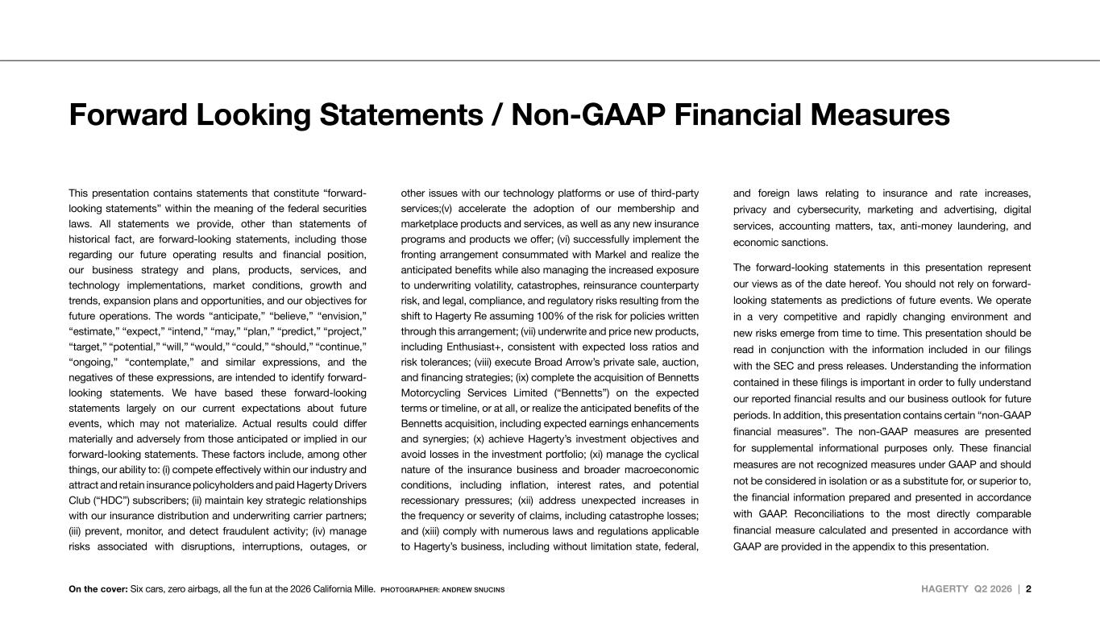
HAGERTY Q2 2026 | 2 Forward Looking Statements / Non-GAAP Financial Measures This presentation contains statements that constitute “forward- looking statements” within the meaning of the federal securities laws. All statements we provide, other than statements of historical fact, are forward-looking statements, including those regarding our future operating results and financial position, our business strategy and plans, products, services, and technology implementations, market conditions, growth and trends, expansion plans and opportunities, and our objectives for future operations. The words “anticipate,” “believe,” “envision,” “estimate,” “expect,” “intend,” “may,” “plan,” “predict,” “project,” “target,” “potential,” “will,” “would,” “could,” “should,” “continue,” “ongoing,” “contemplate,” and similar expressions, and the negatives of these expressions, are intended to identify forward- looking statements. We have based these forward-looking statements largely on our current expectations about future events, which may not materialize. Actual results could differ materially and adversely from those anticipated or implied in our forward-looking statements. These factors include, among other things, our ability to: (i) compete effectively within our industry and attract and retain insurance policyholders and paid Hagerty Drivers Club (“HDC”) subscribers; (ii) maintain key strategic relationships with our insurance distribution and underwriting carrier partners; (iii) prevent, monitor, and detect fraudulent activity; (iv) manage risks associated with disruptions, interruptions, outages, or other issues with our technology platforms or use of third-party services;(v) accelerate the adoption of our membership and marketplace products and services, as well as any new insurance programs and products we offer; (vi) successfully implement the fronting arrangement consummated with Markel and realize the anticipated benefits while also managing the increased exposure to underwriting volatility, catastrophes, reinsurance counterparty risk, and legal, compliance, and regulatory risks resulting from the shift to Hagerty Re assuming 100% of the risk for policies written through this arrangement; (vii) underwrite and price new products, including Enthusiast+, consistent with expected loss ratios and risk tolerances; (viii) execute Broad Arrow’s private sale, auction, and financing strategies; (ix) complete the acquisition of Bennetts Motorcycling Services Limited (“Bennetts”) on the expected terms or timeline, or at all, or realize the anticipated benefits of the Bennetts acquisition, including expected earnings enhancements and synergies; (x) achieve Hagerty’s investment objectives and avoid losses in the investment portfolio; (xi) manage the cyclical nature of the insurance business and broader macroeconomic conditions, including inflation, interest rates, and potential recessionary pressures; (xii) address unexpected increases in the frequency or severity of claims, including catastrophe losses; and (xiii) comply with numerous laws and regulations applicable to Hagerty’s business, including without limitation state, federal, and foreign laws relating to insurance and rate increases, privacy and cybersecurity, marketing and advertising, digital services, accounting matters, tax, anti-money laundering, and economic sanctions. The forward-looking statements in this presentation represent our views as of the date hereof. You should not rely on forward- looking statements as predictions of future events. We operate in a very competitive and rapidly changing environment and new risks emerge from time to time. This presentation should be read in conjunction with the information included in our filings with the SEC and press releases. Understanding the information contained in these filings is important in order to fully understand our reported financial results and our business outlook for future periods. In addition, this presentation contains certain “non-GAAP financial measures”. The non-GAAP measures are presented for supplemental informational purposes only. These financial measures are not recognized measures under GAAP and should not be considered in isolation or as a substitute for, or superior to, the financial information prepared and presented in accordance with GAAP. Reconciliations to the most directly comparable financial measure calculated and presented in accordance with GAAP are provided in the appendix to this presentation. On the cover: Six cars, zero airbags, all the fun at the 2026 California Mille. PHOTOGRAPHER: ANDREW SNUCINS

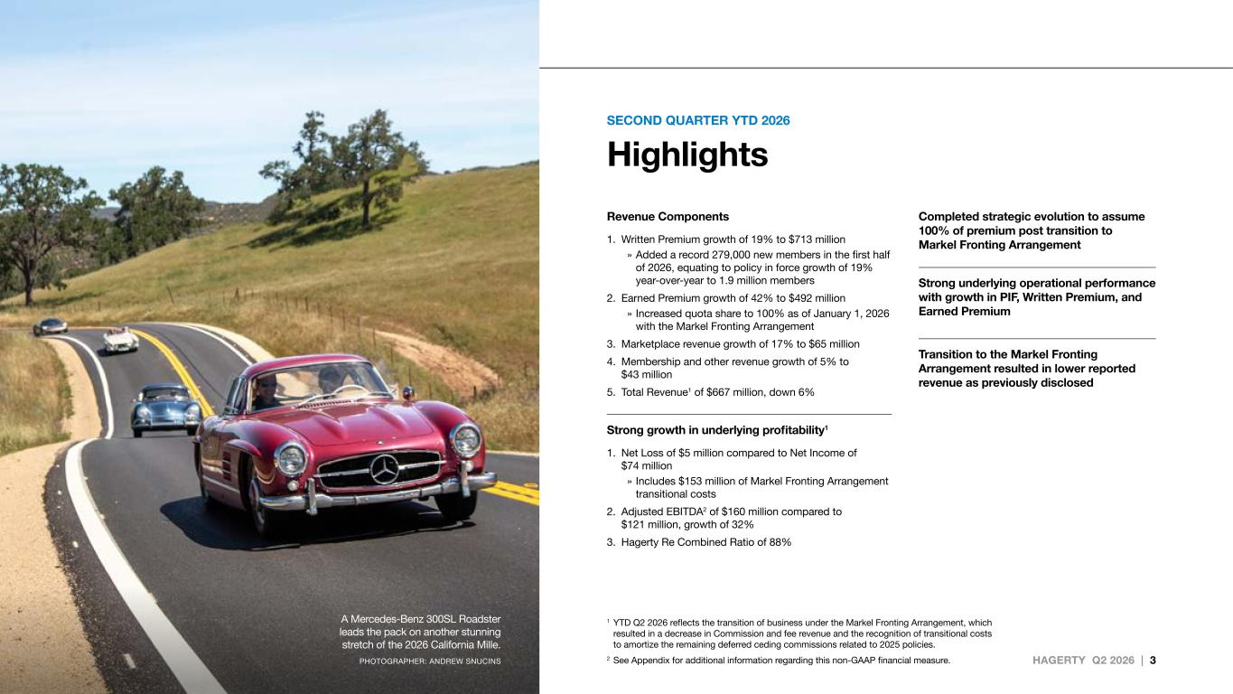
HAGERTY Q2 2026 | 3 SECOND QUARTER YTD 2026 Highlights 1 YTD Q2 2026 reflects the transition of business under the Markel Fronting Arrangement, which resulted in a decrease in Commission and fee revenue and the recognition of transitional costs to amortize the remaining deferred ceding commissions related to 2025 policies. 2 See Appendix for additional information regarding this non-GAAP financial measure. A Mercedes-Benz 300SL Roadster leads the pack on another stunning stretch of the 2026 California Mille. PHOTOGRAPHER: ANDREW SNUCINS Revenue Components 1. Written Premium growth of 19% to $713 million » Added a record 279,000 new members in the first half of 2026, equating to policy in force growth of 19% year-over-year to 1.9 million members 2. Earned Premium growth of 42% to $492 million » Increased quota share to 100% as of January 1, 2026 with the Markel Fronting Arrangement 3. Marketplace revenue growth of 17% to $65 million 4. Membership and other revenue growth of 5% to $43 million 5. Total Revenue1 of $667 million, down 6% Strong growth in underlying profitability1 1. Net Loss of $5 million compared to Net Income of $74 million » Includes $153 million of Markel Fronting Arrangement transitional costs 2. Adjusted EBITDA2 of $160 million compared to $121 million, growth of 32% 3. Hagerty Re Combined Ratio of 88% Completed strategic evolution to assume 100% of premium post transition to Markel Fronting Arrangement Strong underlying operational performance with growth in PIF, Written Premium, and Earned Premium Transition to the Markel Fronting Arrangement resulted in lower reported revenue as previously disclosed

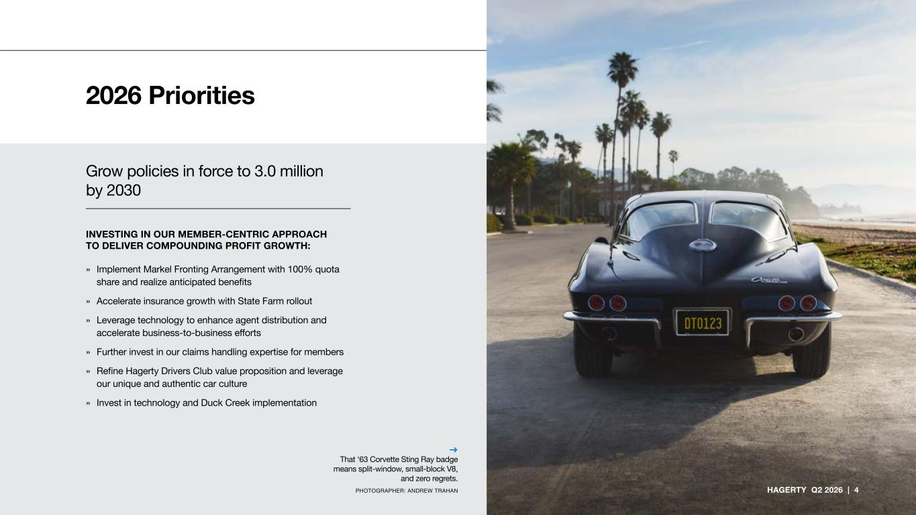
Grow policies in force to 3.0 million by 2030 INVESTING IN OUR MEMBER-CENTRIC APPROACH TO DELIVER COMPOUNDING PROFIT GROWTH: » Implement Markel Fronting Arrangement with 100% quota share and realize anticipated benefits » Accelerate insurance growth with State Farm rollout » Leverage technology to enhance agent distribution and accelerate business-to-business efforts » Further invest in our claims handling expertise for members » Refine Hagerty Drivers Club value proposition and leverage our unique and authentic car culture » Invest in technology and Duck Creek implementation → That ‘63 Corvette Sting Ray badge means split-window, small-block V8, and zero regrets. PHOTOGRAPHER: ANDREW TRAHAN 2026 Priorities HAGERTY Q2 2026 | 4

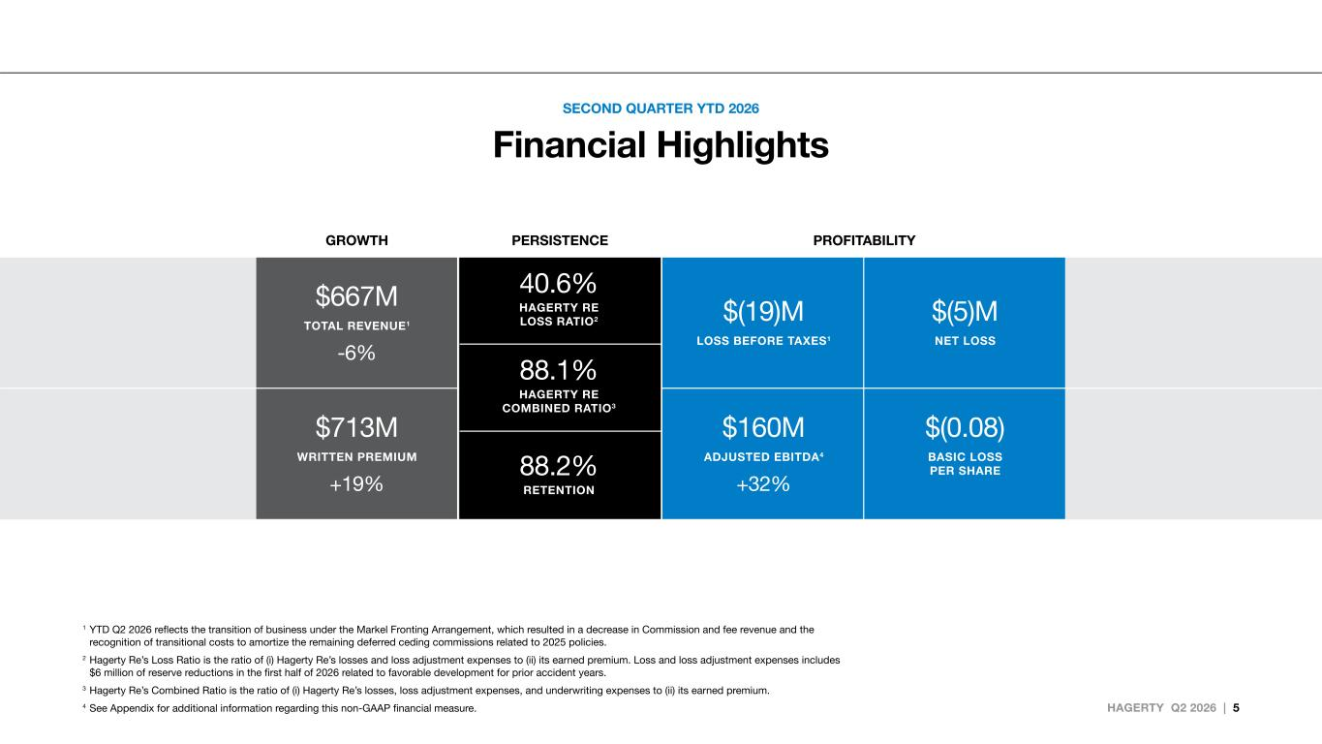
HAGERTY Q2 2026 | 5 SECOND QUARTER YTD 2026 Financial Highlights 1 YTD Q2 2026 reflects the transition of business under the Markel Fronting Arrangement, which resulted in a decrease in Commission and fee revenue and the recognition of transitional costs to amortize the remaining deferred ceding commissions related to 2025 policies. 2 Hagerty Re’s Loss Ratio is the ratio of (i) Hagerty Re’s losses and loss adjustment expenses to (ii) its earned premium. Loss and loss adjustment expenses includes $6 million of reserve reductions in the first half of 2026 related to favorable development for prior accident years. 3 Hagerty Re’s Combined Ratio is the ratio of (i) Hagerty Re’s losses, loss adjustment expenses, and underwriting expenses to (ii) its earned premium. 4 See Appendix for additional information regarding this non-GAAP financial measure. GROWTH PERSISTENCE PROFITABILITY $667M TOTAL REVENUE1 -6% $(19)M LOSS BEFORE TAXES1 $(5)M NET LOSS $713M WRITTEN PREMIUM +19% $160M ADJUSTED EBITDA4 +32% $(0.08) BASIC LOSS PER SHARE 40.6% HAGERTY RE LOSS RATIO2 88.1% HAGERTY RE COMBINED RATIO3 88.2% RETENTION

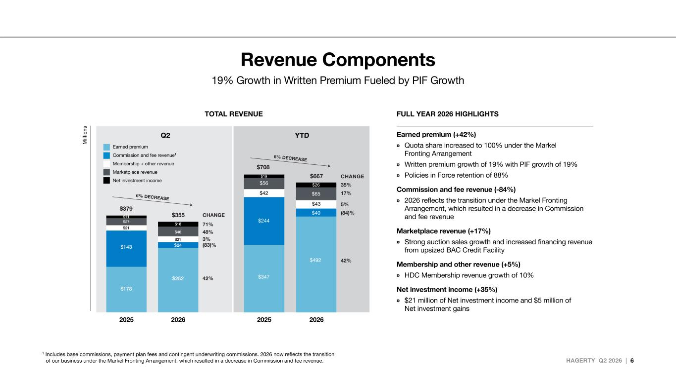
HAGERTY Q2 2026 | 6 Revenue Components 19% Growth in Written Premium Fueled by PIF Growth 1 Includes base commissions, payment plan fees and contingent underwriting commissions. 2026 now reflects the transition of our business under the Markel Fronting Arrangement, which resulted in a decrease in Commission and fee revenue. FULL YEAR 2026 HIGHLIGHTS Earned premium (+42%) » Quota share increased to 100% under the Markel Fronting Arrangement » Written premium growth of 19% with PIF growth of 19% » Policies in Force retention of 88% Commission and fee revenue (-84%) » 2026 reflects the transition under the Markel Fronting Arrangement, which resulted in a decrease in Commission and fee revenue Marketplace revenue (+17%) » Strong auction sales growth and increased financing revenue from upsized BAC Credit Facility Membership and other revenue (+5%) » HDC Membership revenue growth of 10% Net investment income (+35%) » $21 million of Net investment income and $5 million of Net investment gains Q2 YTD 2025 2026 2025 2026 $301 $355 $379 $708 $667 71% 48% 3% 42% (83)% CHANGE 35% 17% 5% 42% (84)% CHANGE 6% DECREASE 6% DECREASE $11 $27 $143 $178 $21 $18 $40 $24 $252 $21 $42 $43 $56 $19 $347 $492 $244 $40 $65 $26 2025 2026 2025 2026 $301 $355 $379 $708 $667 71% 48% 3% 42% (83)% CHANGE 35% 17% 5% 42% (84)% CHANGE 6% DECREAS 6% DECREAS $11 $27 $143 $178 $21 $18 $40 $24 $252 $21 $42 $43 $56 $19 $347 $492 $244 $40 $65 $26 TOTAL REVENUE Earned premium Commission and fee revenue1 Membership + other revenue Marketplace revenue Net investment income

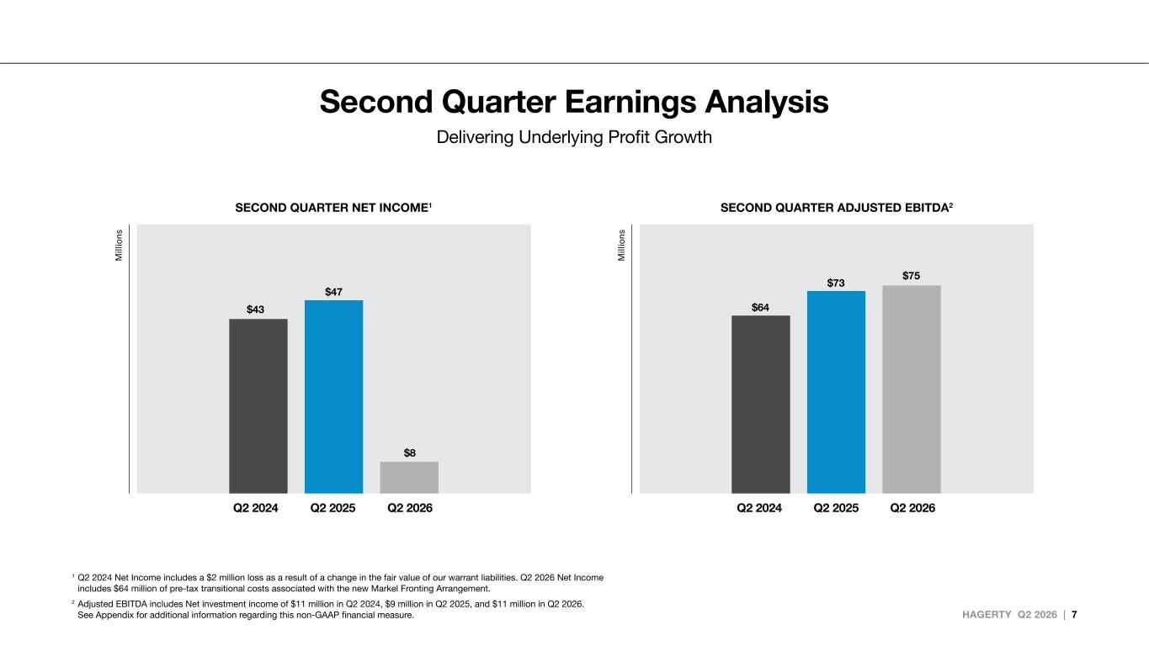
HAGERTY Q2 2026 | 7 Q2 2024 Q2 2025 Q2 2026Q2 2024 Q2 2025 Q2 2026 1 Q2 2024 Net Income includes a $2 million loss as a result of a change in the fair value of our warrant liabilities. Q2 2026 Net Income includes $64 million of pre-tax transitional costs associated with the new Markel Fronting Arrangement. 2 Adjusted EBITDA includes Net investment income of $11 million in Q2 2024, $9 million in Q2 2025, and $11 million in Q2 2026. See Appendix for additional information regarding this non-GAAP financial measure. Second Quarter Earnings Analysis Delivering Underlying Profit Growth SECOND QUARTER NET INCOME1 SECOND QUARTER ADJUSTED EBITDA2 $43 $47 $8 YTD Q2 2024 YTD Q2 2025 YTD Q2 2026 $64 $73 $75 YTD Q2 2024 YTD Q2 2025 YTD Q2 2026

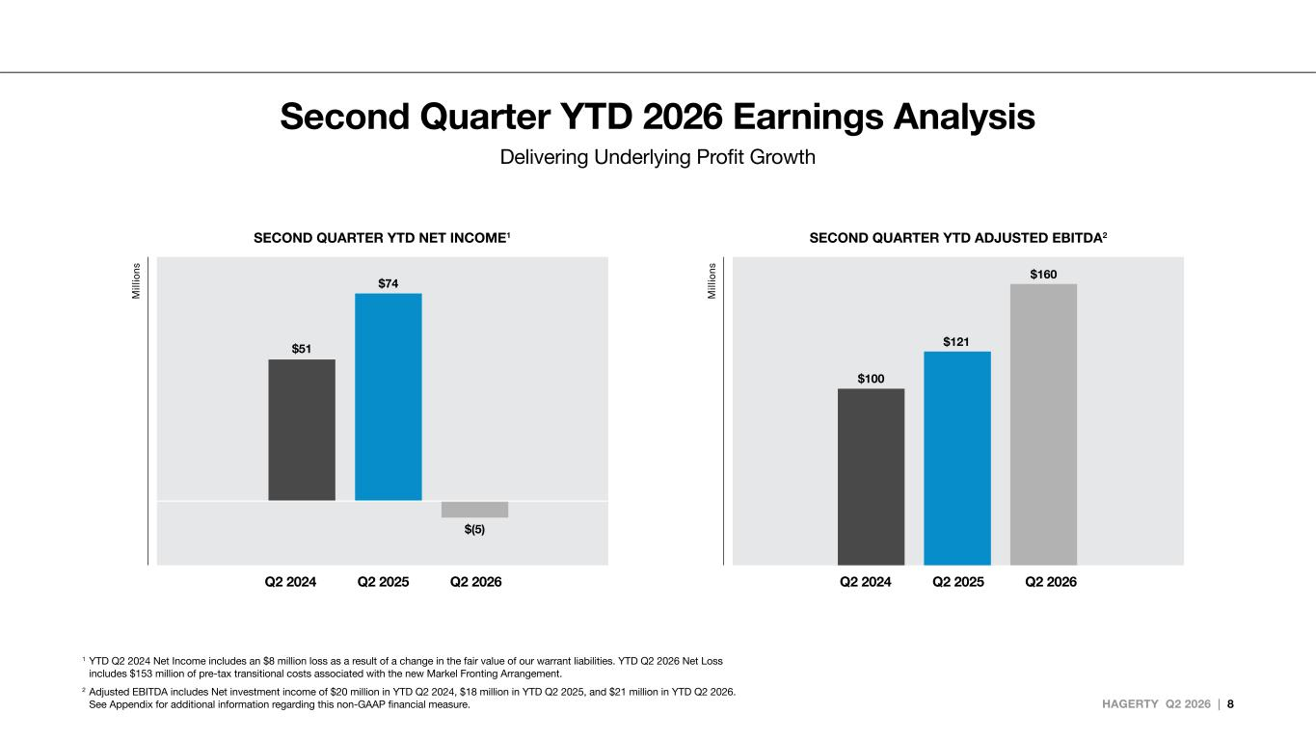
HAGERTY Q2 2026 | 8 Q2 2024 Q2 2025 Q2 2026 Q2 2024 Q2 2025 Q2 2026 1 YTD Q2 2024 Net Income includes an $8 million loss as a result of a change in the fair value of our warrant liabilities. YTD Q2 2026 Net Loss includes $153 million of pre-tax transitional costs associated with the new Markel Fronting Arrangement. 2 Adjusted EBITDA includes Net investment income of $20 million in YTD Q2 2024, $18 million in YTD Q2 2025, and $21 million in YTD Q2 2026. See Appendix for additional information regarding this non-GAAP financial measure. Second Quarter YTD 2026 Earnings Analysis Delivering Underlying Profit Growth SECOND QUARTER YTD NET INCOME1 SECOND QUARTER YTD ADJUSTED EBITDA2 Q2 2024 Q2 2025 Q2 2026 $51 $74 $(5) Q2 2024 Q2 2025 Q2 2026 $100 $121 $160

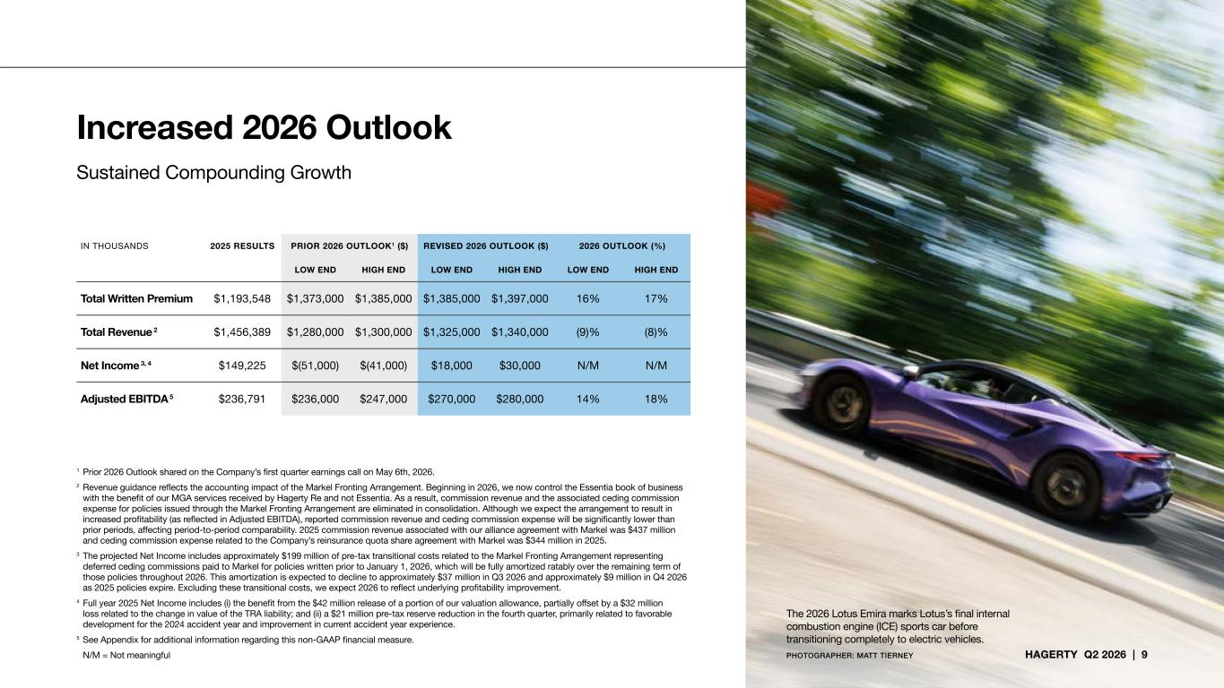
HAGERTY Q2 2026 | 9 Increased 2026 Outlook 1 Prior 2026 Outlook shared on the Company’s first quarter earnings call on May 6th, 2026. 2 Revenue guidance reflects the accounting impact of the Markel Fronting Arrangement. Beginning in 2026, we now control the Essentia book of business with the benefit of our MGA services received by Hagerty Re and not Essentia. As a result, commission revenue and the associated ceding commission expense for policies issued through the Markel Fronting Arrangement are eliminated in consolidation. Although we expect the arrangement to result in increased profitability (as reflected in Adjusted EBITDA), reported commission revenue and ceding commission expense will be significantly lower than prior periods, affecting period-to-period comparability. 2025 commission revenue associated with our alliance agreement with Markel was $437 million and ceding commission expense related to the Company’s reinsurance quota share agreement with Markel was $344 million in 2025. 3 The projected Net Income includes approximately $199 million of pre-tax transitional costs related to the Markel Fronting Arrangement representing deferred ceding commissions paid to Markel for policies written prior to January 1, 2026, which will be fully amortized ratably over the remaining term of those policies throughout 2026. This amortization is expected to decline to approximately $37 million in Q3 2026 and approximately $9 million in Q4 2026 as 2025 policies expire. Excluding these transitional costs, we expect 2026 to reflect underlying profitability improvement. 4 Full year 2025 Net Income includes (i) the benefit from the $42 million release of a portion of our valuation allowance, partially offset by a $32 million loss related to the change in value of the TRA liability; and (ii) a $21 million pre-tax reserve reduction in the fourth quarter, primarily related to favorable development for the 2024 accident year and improvement in current accident year experience. 5 See Appendix for additional information regarding this non-GAAP financial measure. N/M = Not meaningful Sustained Compounding Growth IN THOUSANDS 2025 RESULTS PRIOR 2026 OUTLOOK1 ($) REVISED 2026 OUTLOOK ($) 2026 OUTLOOK (%) LOW END HIGH END LOW END HIGH END LOW END HIGH END Total Written Premium $1,193,548 $1,373,000 $1,385,000 $1,385,000 $1,397,000 16% 17% Total Revenue 2 $1,456,389 $1,280,000 $1,300,000 $1,325,000 $1,340,000 (9)% (8)% Net Income 3, 4 $149,225 $(51,000) $(41,000) $18,000 $30,000 N/M N/M Adjusted EBITDA 5 $236,791 $236,000 $247,000 $270,000 $280,000 14% 18% The 2026 Lotus Emira marks Lotus’s final internal combustion engine (ICE) sports car before transitioning completely to electric vehicles. PHOTOGRAPHER: MATT TIERNEY

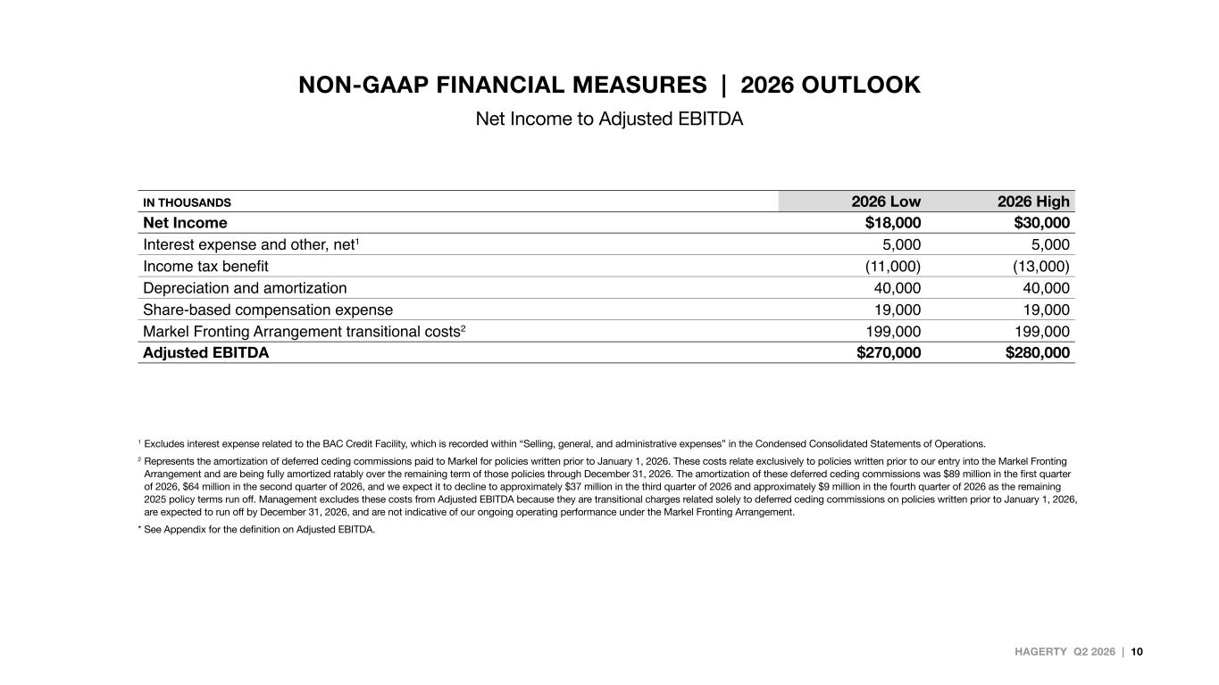
HAGERTY Q2 2026 | 10 NON-GAAP FINANCIAL MEASURES | 2026 OUTLOOK Net Income to Adjusted EBITDA IN THOUSANDS 2026 Low 2026 High Net Income $18,000 $30,000 Interest expense and other, net1 5,000 5,000 Income tax benefit (11,000) (13,000) Depreciation and amortization 40,000 40,000 Share-based compensation expense 19,000 19,000 Markel Fronting Arrangement transitional costs2 199,000 199,000 Adjusted EBITDA $270,000 $280,000 1 Excludes interest expense related to the BAC Credit Facility, which is recorded within “Selling, general, and administrative expenses” in the Condensed Consolidated Statements of Operations. 2 Represents the amortization of deferred ceding commissions paid to Markel for policies written prior to January 1, 2026. These costs relate exclusively to policies written prior to our entry into the Markel Fronting Arrangement and are being fully amortized ratably over the remaining term of those policies through December 31, 2026. The amortization of these deferred ceding commissions was $89 million in the first quarter of 2026, $64 million in the second quarter of 2026, and we expect it to decline to approximately $37 million in the third quarter of 2026 and approximately $9 million in the fourth quarter of 2026 as the remaining 2025 policy terms run off. Management excludes these costs from Adjusted EBITDA because they are transitional charges related solely to deferred ceding commissions on policies written prior to January 1, 2026, are expected to run off by December 31, 2026, and are not indicative of our ongoing operating performance under the Markel Fronting Arrangement. * See Appendix for the definition on Adjusted EBITDA.

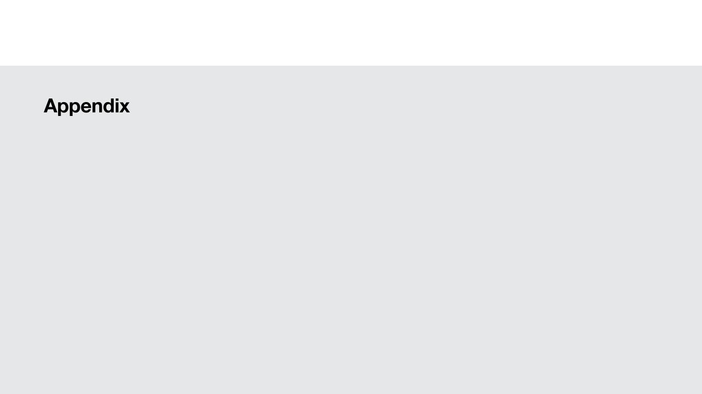
Appendix

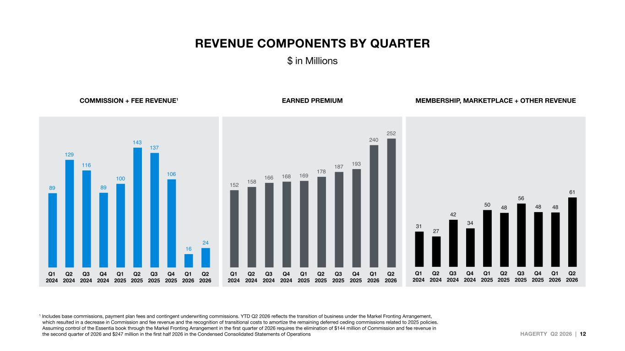
HAGERTY Q2 2026 | 12 REVENUE COMPONENTS BY QUARTER $ in Millions 152 158 166 168 169 178 187 193 240 252 Q1 2024 Q2 2024 Q3 2024 Q4 2024 Q1 2025 Q2 2025 Q3 2025 Q4 2025 Q1 2026 Q2 2026 89 129 116 89 100 143 137 106 16 24 Q1 2024 Q2 2024 Q3 2024 Q4 2024 Q1 2025 Q2 2025 Q3 2025 Q4 2025 Q1 2026 Q2 2026 31 27 42 34 50 48 56 48 48 61 Q1 2024 Q2 2024 Q3 2024 Q4 2024 Q1 2025 Q2 2025 Q3 2025 Q4 2025 Q1 2026 Q2 2026 COMMISSION + FEE REVENUE1 EARNED PREMIUM MEMBERSHIP, MARKETPLACE + OTHER REVENUE 1 Includes base commissions, payment plan fees and contingent underwriting commissions. YTD Q2 2026 reflects the transition of business under the Markel Fronting Arrangement, which resulted in a decrease in Commission and fee revenue and the recognition of transitional costs to amortize the remaining deferred ceding commissions related to 2025 policies. Assuming control of the Essentia book through the Markel Fronting Arrangement in the first quarter of 2026 requires the elimination of $144 million of Commission and fee revenue in the second quarter of 2026 and $247 million in the first half 2026 in the Condensed Consolidated Statements of Operations

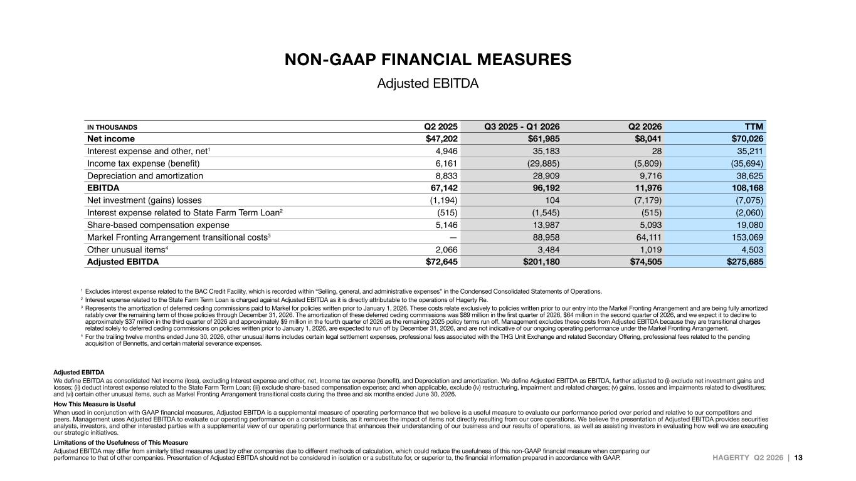
HAGERTY Q2 2026 | 13 IN THOUSANDS Q2 2025 Q3 2025 - Q1 2026 Q2 2026 TTM Net income $47,202 $61,985 $8,041 $70,026 Interest expense and other, net1 4,946 35,183 28 35,211 Income tax expense (benefit) 6,161 (29,885) (5,809) (35,694) Depreciation and amortization 8,833 28,909 9,716 38,625 EBITDA 67,142 96,192 11,976 108,168 Net investment (gains) losses (1,194) 104 (7,179) (7,075) Interest expense related to State Farm Term Loan2 (515) (1,545) (515) (2,060) Share-based compensation expense 5,146 13,987 5,093 19,080 Markel Fronting Arrangement transitional costs3 — 88,958 64,111 153,069 Other unusual items4 2,066 3,484 1,019 4,503 Adjusted EBITDA $72,645 $201,180 $74,505 $275,685 1 Excludes interest expense related to the BAC Credit Facility, which is recorded within “Selling, general, and administrative expenses” in the Condensed Consolidated Statements of Operations. 2 Interest expense related to the State Farm Term Loan is charged against Adjusted EBITDA as it is directly attributable to the operations of Hagerty Re. 3 Represents the amortization of deferred ceding commissions paid to Markel for policies written prior to January 1, 2026. These costs relate exclusively to policies written prior to our entry into the Markel Fronting Arrangement and are being fully amortized ratably over the remaining term of those policies through December 31, 2026. The amortization of these deferred ceding commissions was $89 million in the first quarter of 2026, $64 million in the second quarter of 2026, and we expect it to decline to approximately $37 million in the third quarter of 2026 and approximately $9 million in the fourth quarter of 2026 as the remaining 2025 policy terms run off. Management excludes these costs from Adjusted EBITDA because they are transitional charges related solely to deferred ceding commissions on policies written prior to January 1, 2026, are expected to run off by December 31, 2026, and are not indicative of our ongoing operating performance under the Markel Fronting Arrangement. 4 For the trailing twelve months ended June 30, 2026, other unusual items includes certain legal settlement expenses, professional fees associated with the THG Unit Exchange and related Secondary Offering, professional fees related to the pending acquisition of Bennetts, and certain material severance expenses. Adjusted EBITDA We define EBITDA as consolidated Net income (loss), excluding Interest expense and other, net, Income tax expense (benefit), and Depreciation and amortization. We define Adjusted EBITDA as EBITDA, further adjusted to (i) exclude net investment gains and losses; (ii) deduct interest expense related to the State Farm Term Loan; (iii) exclude share-based compensation expense; and when applicable, exclude (iv) restructuring, impairment and related charges; (v) gains, losses and impairments related to divestitures; and (vi) certain other unusual items, such as Markel Fronting Arrangement transitional costs during the three and six months ended June 30, 2026. How This Measure is Useful When used in conjunction with GAAP financial measures, Adjusted EBITDA is a supplemental measure of operating performance that we believe is a useful measure to evaluate our performance period over period and relative to our competitors and peers. Management uses Adjusted EBITDA to evaluate our operating performance on a consistent basis, as it removes the impact of items not directly resulting from our core operations. We believe the presentation of Adjusted EBITDA provides securities analysts, investors, and other interested parties with a supplemental view of our operating performance that enhances their understanding of our business and our results of operations, as well as assisting investors in evaluating how well we are executing our strategic initiatives. Limitations of the Usefulness of This Measure Adjusted EBITDA may differ from similarly titled measures used by other companies due to different methods of calculation, which could reduce the usefulness of this non-GAAP financial measure when comparing our performance to that of other companies. Presentation of Adjusted EBITDA should not be considered in isolation or a substitute for, or superior to, the financial information prepared in accordance with GAAP. NON-GAAP FINANCIAL MEASURES Adjusted EBITDA

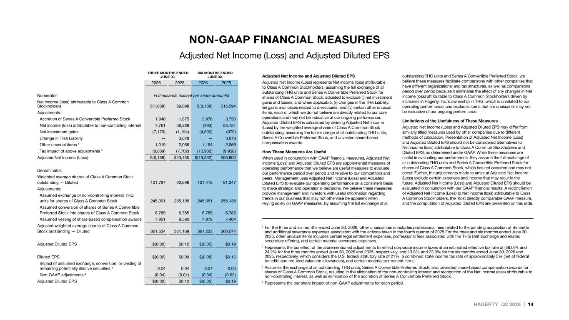
HAGERTY Q2 2026 | 14 1 For the three and six months ended June 30, 2026, other unusual items includes professional fees related to the pending acquisition of Bennetts and additional severance expenses associated with the actions taken in the fourth quarter of 2025.For the three and six months ended June 30, 2025, other unusual items includes certain legal settlement expenses, professional fees associated with the THG Unit Exchange and related secondary offering, and certain material severance expenses. 2 Represents the tax effect of the aforementioned adjustments to reflect corporate income taxes at an estimated effective tax rate of (58.0)% and 24.2% for the three months ended June 30, 2026 and 2025, respectively, and 13.8% and 23.9% for the six months ended June 30, 2026 and 2025, respectively, which considers the U.S. federal statutory rate of 21%, a combined state income tax rate of approximately 5% (net of federal benefits and required valuation allowances), and certain material permanent items. 3 Assumes the exchange of all outstanding THG units, Series A Convertible Preferred Stock, and unvested share-based compensation awards for shares of Class A Common Stock, resulting in the elimination of the non-controlling interest and recognition of the Net income (loss) attributable to non-controlling interest, as well as elimination of the accretion of Series A Convertible Preferred Stock. 4 Represents the per share impact of non-GAAP adjustments for each period. Adjusted Net Income and Adjusted Diluted EPS Adjusted Net Income (Loss) represents Net income (loss) attributable to Class A Common Stockholders, assuming the full exchange of all outstanding THG units and Series A Convertible Preferred Stock for shares of Class A Common Stock, adjusted to exclude (i) net investment gains and losses; and when applicable, (ii) changes in the TRA Liability; (iii) gains and losses related to divestitures; and (iv) certain other unusual items, each of which we do not believe are directly related to our core operations and may not be indicative of our ongoing performance. Adjusted Diluted EPS is calculated by dividing Adjusted Net Income (Loss) by the weighted average shares of Class A Common Stock outstanding, assuming the full exchange of all outstanding THG units, Series A Convertible Preferred Stock, and unvested share-based compensation awards. How These Measures Are Useful When used in conjunction with GAAP financial measures, Adjusted Net Income (Loss) and Adjusted Diluted EPS are supplemental measures of operating performance that we believe are useful measures to evaluate our performance period over period and relative to our competitors and peers. Management uses Adjusted Net Income (Loss) and Adjusted Diluted EPS to evaluate our operating performance on a consistent basis to make strategic and operational decisions. We believe these measures provide management and investors with useful information regarding trends in our business that may not otherwise be apparent when relying solely on GAAP measures. By assuming the full exchange of all outstanding THG units and Series A Convertible Preferred Stock, we believe these measures facilitate comparisons with other companies that have different organizational and tax structures, as well as comparisons period over period because it eliminates the effect of any changes in Net income (loss) attributable to Class A Common Stockholders driven by increases in Hagerty, Inc.’s ownership in THG, which is unrelated to our operating performance, and excludes items that are unusual or may not be indicative of our ongoing performance. Limitations of the Usefulness of These Measures Adjusted Net Income (Loss) and Adjusted Diluted EPS may differ from similarly titled measures used by other companies due to different methods of calculation. Presentation of Adjusted Net Income (Loss) and Adjusted Diluted EPS should not be considered alternatives to Net income (loss) attributable to Class A Common Stockholders and Diluted EPS, as determined under GAAP. While these measures are useful in evaluating our performance, they assume the full exchange of all outstanding THG units and Series A Convertible Preferred Stock for shares of Class A Common Stock, which has not occurred and may not occur. Further, the adjustments made to arrive at Adjusted Net Income (Loss) exclude certain expenses and income that may recur in the future. Adjusted Net Income (Loss) and Adjusted Diluted EPS should be evaluated in conjunction with our GAAP financial results. A reconciliation of Adjusted Net Income (Loss) to Net income (loss) attributable to Class A Common Stockholders, the most directly comparable GAAP measure, and the computation of Adjusted Diluted EPS are presented on this slide. THREE MONTHS ENDED JUNE 30, SIX MONTHS ENDED JUNE 30, 2026 2025 2026 2025 Numerator: in thousands (except per share amounts) Net income (loss) attributable to Class A Common Stockholders $(1,668) $9,098 $(8,189) $15,594 Adjustments: Accretion of Series A Convertible Preferred Stock 1,948 1,875 3,978 3,750 Net income (loss) attributable to non-controlling interest 7,761 36,229 (493) 55,151 Net investment gains (7,179) (1,194) (4,890) (879) Change in TRA Liability — 3,078 — 3,078 Other unusual items 1 1,019 2,066 1,164 2,066 Tax impact of above adjustments 2 (8,069) (7,702) (10,902) (9,958) Adjusted Net Income (Loss) $(6,188) $43,450 $(19,332) $68,802 Denominator: Weighted average shares of Class A Common Stock outstanding — Diluted 101,797 90,698 101,418 91,247 Adjustments: Assumed exchange of non-controlling interest THG units for shares of Class A Common Stock 245,001 255,105 245,051 255,138 Assumed conversion of shares of Series A Convertible Preferred Stock into shares of Class A Common Stock 6,785 6,785 6,785 6,785 Assumed vesting of share-based compensation awards 7,951 8,580 7,979 7,404 Adjusted weighted average shares of Class A Common Stock outstanding — Diluted 361,534 361,168 361,233 360,574 Adjusted Diluted EPS $(0.02) $0.12 $(0.05) $0.19 Diluted EPS $(0.02) $0.09 $(0.08) $0.16 Impact of assumed exchange, conversion, or vesting of remaining potentially dilutive securities 3 0.04 0.04 0.07 0.05 Non-GAAP adjustments 4 (0.04) (0.01) (0.04) (0.02) Adjusted Diluted EPS $(0.02) $0.12 $(0.05) $0.19 THREE MONTHS ENDED JU 0, SIX MONTHS ENDED JUN , NON-GAAP FINANCIAL MEASURES Adjusted Net Income (Loss) and Adjusted Diluted EPS

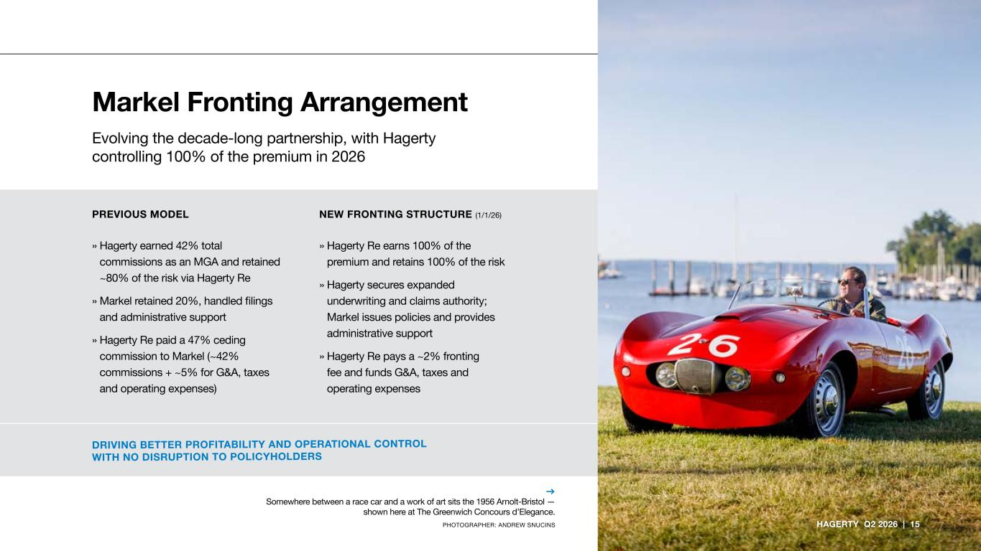
Markel Fronting Arrangement Evolving the decade-long partnership, with Hagerty controlling 100% of the premium in 2026 HAGERTY Q2 2026 | 15 → Somewhere between a race car and a work of art sits the 1956 Arnolt-Bristol — shown here at The Greenwich Concours d’Elegance. PHOTOGRAPHER: ANDREW SNUCINS DRIVING BETTER PROFITABILITY AND OPERATIONAL CONTROL WITH NO DISRUPTION TO POLICYHOLDERS PREVIOUS MODEL NEW FRONTING STRUCTURE (1/1/26) » Hagerty earned 42% total commissions as an MGA and retained ~80% of the risk via Hagerty Re » Markel retained 20%, handled filings and administrative support » Hagerty Re paid a 47% ceding commission to Markel (~42% commissions + ~5% for G&A, taxes and operating expenses) » Hagerty Re earns 100% of the premium and retains 100% of the risk » Hagerty secures expanded underwriting and claims authority; Markel issues policies and provides administrative support » Hagerty Re pays a ~2% fronting fee and funds G&A, taxes and operating expenses

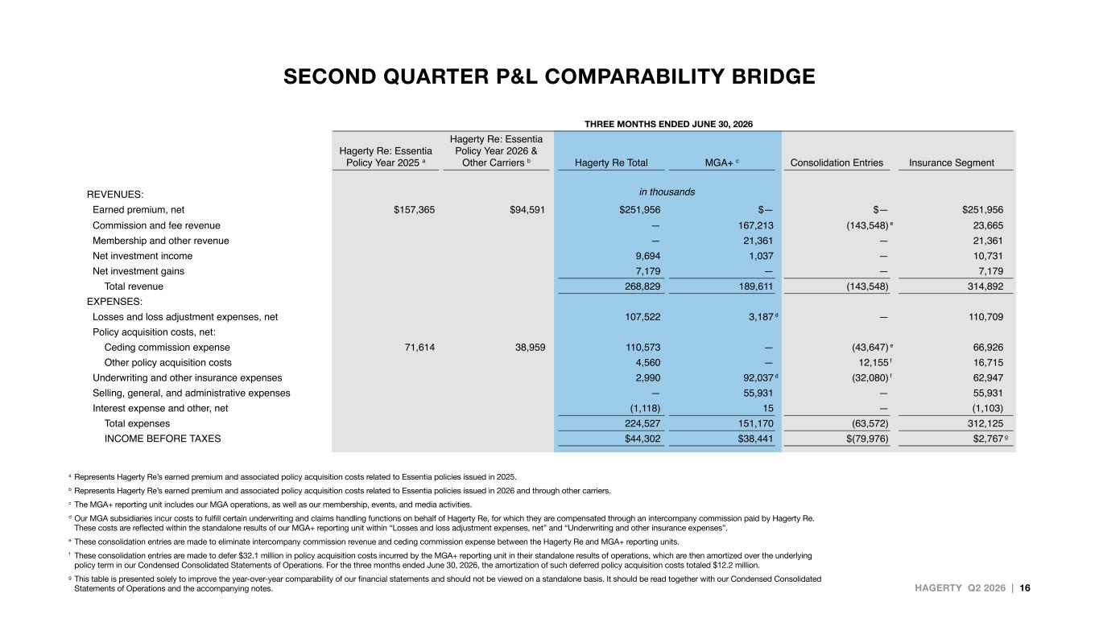
HAGERTY Q2 2026 | 16 SECOND QUARTER P&L COMPARABILITY BRIDGE a Represents Hagerty Re’s earned premium and associated policy acquisition costs related to Essentia policies issued in 2025. b Represents Hagerty Re’s earned premium and associated policy acquisition costs related to Essentia policies issued in 2026 and through other carriers. c The MGA+ reporting unit includes our MGA operations, as well as our membership, events, and media activities. d Our MGA subsidiaries incur costs to fulfill certain underwriting and claims handling functions on behalf of Hagerty Re, for which they are compensated through an intercompany commission paid by Hagerty Re. These costs are reflected within the standalone results of our MGA+ reporting unit within “Losses and loss adjustment expenses, net” and “Underwriting and other insurance expenses”. e These consolidation entries are made to eliminate intercompany commission revenue and ceding commission expense between the Hagerty Re and MGA+ reporting units. f These consolidation entries are made to defer $32.1 million in policy acquisition costs incurred by the MGA+ reporting unit in their standalone results of operations, which are then amortized over the underlying policy term in our Condensed Consolidated Statements of Operations. For the three months ended June 30, 2026, the amortization of such deferred policy acquisition costs totaled $12.2 million. g This table is presented solely to improve the year-over-year comparability of our financial statements and should not be viewed on a standalone basis. It should be read together with our Condensed Consolidated Statements of Operations and the accompanying notes. THREE MONTHS ENDED JUNE 30, 2026 Hagerty Re: Essentia Policy Year 2025 a Hagerty Re: Essentia Policy Year 2026 & Other Carriers b Hagerty Re Total MGA+ c Consolidation Entries Insurance Segment REVENUES: in thousands Earned premium, net $157,365 $94,591 $251,956 $— $— $251,956 Commission and fee revenue — 167,213 (143,548) e 23,665 Membership and other revenue — 21,361 — 21,361 Net investment income 9,694 1,037 — 10,731 Net investment gains 7,179 — — 7,179 Total revenue 268,829 189,611 (143,548) 314,892 EXPENSES: Losses and loss adjustment expenses, net 107,522 3,187 d — 110,709 Policy acquisition costs, net: Ceding commission expense 71,614 38,959 110,573 — (43,647) e 66,926 Other policy acquisition costs 4,560 — 12,155 f 16,715 Underwriting and other insurance expenses 2,990 92,037 d (32,080) f 62,947 Selling, general, and administrative expenses — 55,931 — 55,931 Interest expense and other, net (1,118) 15 — (1,103) Total expenses 224,527 151,170 (63,572) 312,125 INCOME BEFORE TAXES $44,302 $38,441 $(79,976) $2,767 g

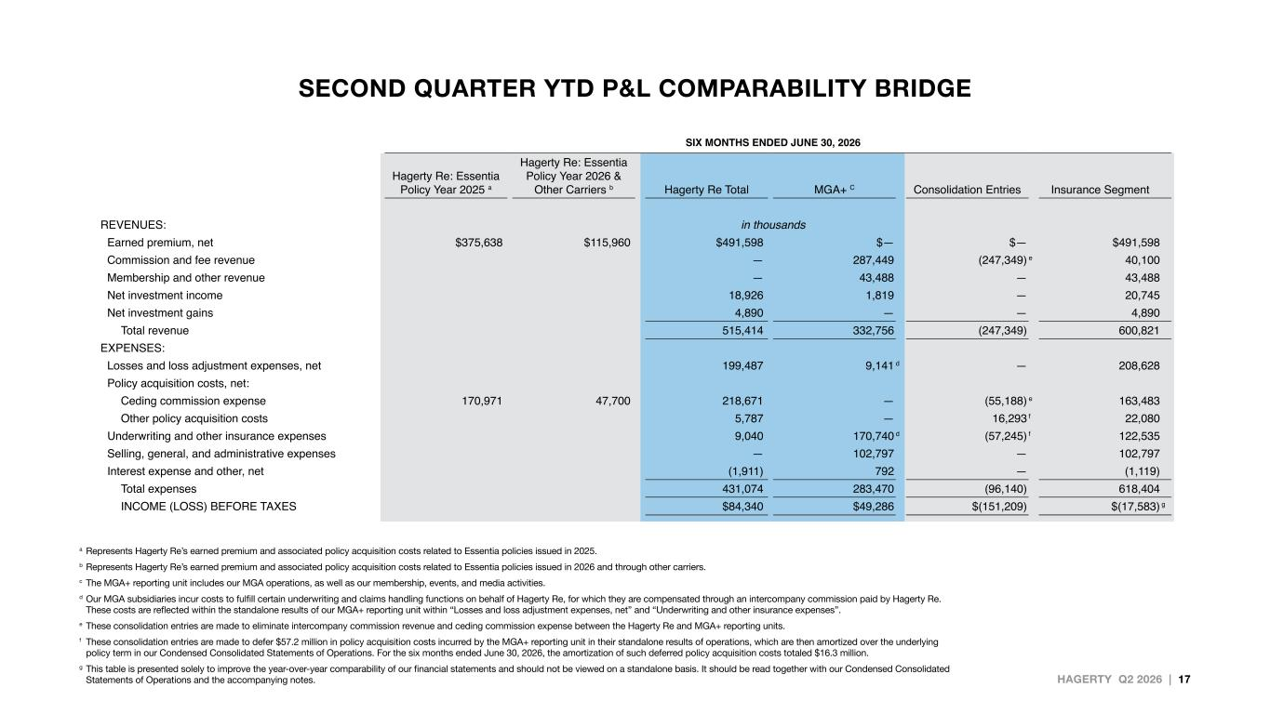
HAGERTY Q2 2026 | 17 SECOND QUARTER YTD P&L COMPARABILITY BRIDGE a Represents Hagerty Re’s earned premium and associated policy acquisition costs related to Essentia policies issued in 2025. b Represents Hagerty Re’s earned premium and associated policy acquisition costs related to Essentia policies issued in 2026 and through other carriers. c The MGA+ reporting unit includes our MGA operations, as well as our membership, events, and media activities. d Our MGA subsidiaries incur costs to fulfill certain underwriting and claims handling functions on behalf of Hagerty Re, for which they are compensated through an intercompany commission paid by Hagerty Re. These costs are reflected within the standalone results of our MGA+ reporting unit within “Losses and loss adjustment expenses, net” and “Underwriting and other insurance expenses”. e These consolidation entries are made to eliminate intercompany commission revenue and ceding commission expense between the Hagerty Re and MGA+ reporting units. f These consolidation entries are made to defer $57.2 million in policy acquisition costs incurred by the MGA+ reporting unit in their standalone results of operations, which are then amortized over the underlying policy term in our Condensed Consolidated Statements of Operations. For the six months ended June 30, 2026, the amortization of such deferred policy acquisition costs totaled $16.3 million. g This table is presented solely to improve the year-over-year comparability of our financial statements and should not be viewed on a standalone basis. It should be read together with our Condensed Consolidated Statements of Operations and the accompanying notes. SIX MONTHS ENDED JUNE 30, 2026 Hagerty Re: Essentia Policy Year 2025 a Hagerty Re: Essentia Policy Year 2026 & Other Carriers b Hagerty Re Total MGA+ C Consolidation Entries Insurance Segment REVENUES: in thousands Earned premium, net $375,638 $115,960 $491,598 $— $— $491,598 Commission and fee revenue — 287,449 (247,349) e 40,100 Membership and other revenue — 43,488 — 43,488 Net investment income 18,926 1,819 — 20,745 Net investment gains 4,890 — — 4,890 Total revenue 515,414 332,756 (247,349) 600,821 EXPENSES: Losses and loss adjustment expenses, net 199,487 9,141 d — 208,628 Policy acquisition costs, net: Ceding commission expense 170,971 47,700 218,671 — (55,188) e 163,483 Other policy acquisition costs 5,787 — 16,293 f 22,080 Underwriting and other insurance expenses 9,040 170,740 d (57,245) f 122,535 Selling, general, and administrative expenses — 102,797 — 102,797 Interest expense and other, net (1,911) 792 — (1,119) Total expenses 431,074 283,470 (96,140) 618,404 INCOME (LOSS) BEFORE TAXES $84,340 $49,286 $(151,209) $(17,583) g

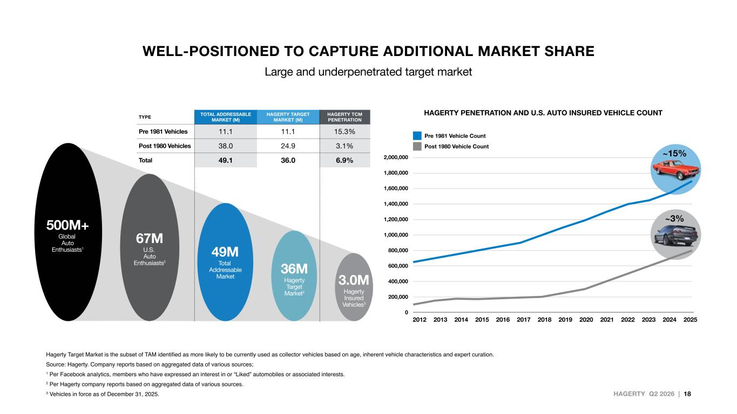
HAGERTY Q2 2026 | 18 WELL-POSITIONED TO CAPTURE ADDITIONAL MARKET SHARE Large and underpenetrated target market Hagerty Target Market is the subset of TAM identified as more likely to be currently used as collector vehicles based on age, inherent vehicle characteristics and expert curation. Source: Hagerty. Company reports based on aggregated data of various sources; 1 Per Facebook analytics, members who have expressed an interest in or “Liked” automobiles or associated interests. 2 Per Hagerty company reports based on aggregated data of various sources. 3 Vehicles in force as of December 31, 2025. TYPE TOTAL ADDRESSABLE MARKET (M) HAGERTY TARGET MARKET (M) HAGERTY TCM PENETRATION Pre 1981 Vehicles 11.1 11.1 15.3% Post 1980 Vehicles 38.0 24.9 3.1% Total 49.1 36.0 6.9% 3.0M Hagerty Insured Vehicles3 36M Hagerty Target Market2 49M Total Addressable Market 67M U.S. Auto Enthusiasts2 500M+ Global Auto Enthusiasts1 HAGERTY PENETRATION AND U.S. AUTO INSURED VEHICLE COUNT Pre 1981 Vehicle Count Post 1980 Vehicle Count 0 200,000 400,000 600,000 800,000 1,000,000 1,200,000 1,400,000 1,600,000 1,800,000 2,000,000 2012 2013 2014 2015 2016 2017 2018 2019 2020 2021 2022 2023 2024 2025 ~3% ~15%

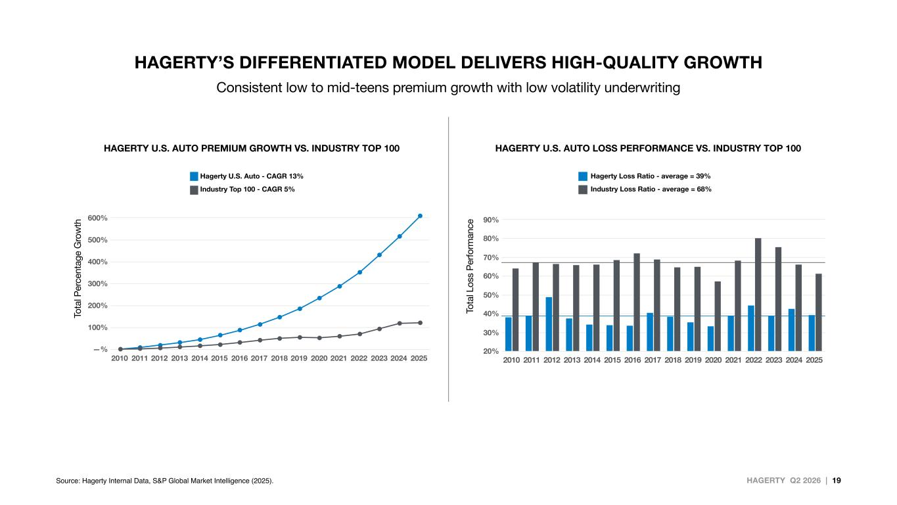
HAGERTY Q2 2026 | 19 2010 2011 2012 2013 2014 2015 2016 2017 2018 2019 2020 2021 2022 2023 2024 2025 —% 100% 200% 300% 400% 500% 600% Hagerty U.S. Auto - CAGR 13% Industry Top 100 - CAGR 5% Hagerty Loss Ratio - average = 39% Industry Loss Ratio - average = 68% HAGERTY U.S. AUTO PREMIUM GROWTH VS. INDUSTRY TOP 100 HAGERTY U.S. AUTO LOSS PERFORMANCE VS. INDUSTRY TOP 100 Source: Hagerty Internal Data, S&P Global Market Intelligence (2025). To ta l P er ce nt ag e G ro w th To ta l L os s P er fo rm an ce 2010 2011 2012 2013 2014 2015 2016 2017 2018 2019 2020 2021 2022 2023 2024 2025 20% 30% 40% 50% 60% 70% 80% 90% HAGERTY’S DIFFERENTIATED MODEL DELIVERS HIGH-QUALITY GROWTH Consistent low to mid-teens premium growth with low volatility underwriting

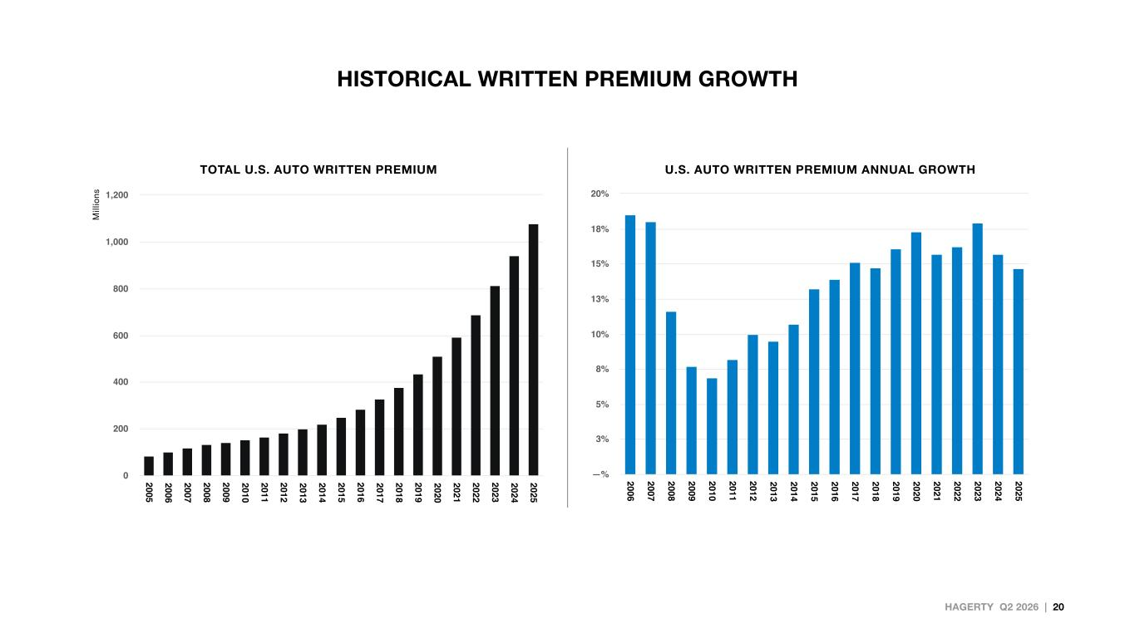
HAGERTY Q2 2026 | 20 HISTORICAL WRITTEN PREMIUM GROWTH 2005 2006 2007 2008 2009 2010 2011 2012 2013 2014 2015 2016 2017 2018 2019 2020 2021 2022 2023 2024 2025 0 200 400 600 800 1,000 1,200 2006 2007 2008 2009 2010 2011 2012 2013 2014 2015 2016 2017 2018 2019 2020 2021 2022 2023 2024 2025 —% 3% 5% 8% 10% 13% 15% 18% 20% TOTAL U.S. AUTO WRITTEN PREMIUM U.S. AUTO WRITTEN PREMIUM ANNUAL GROWTH

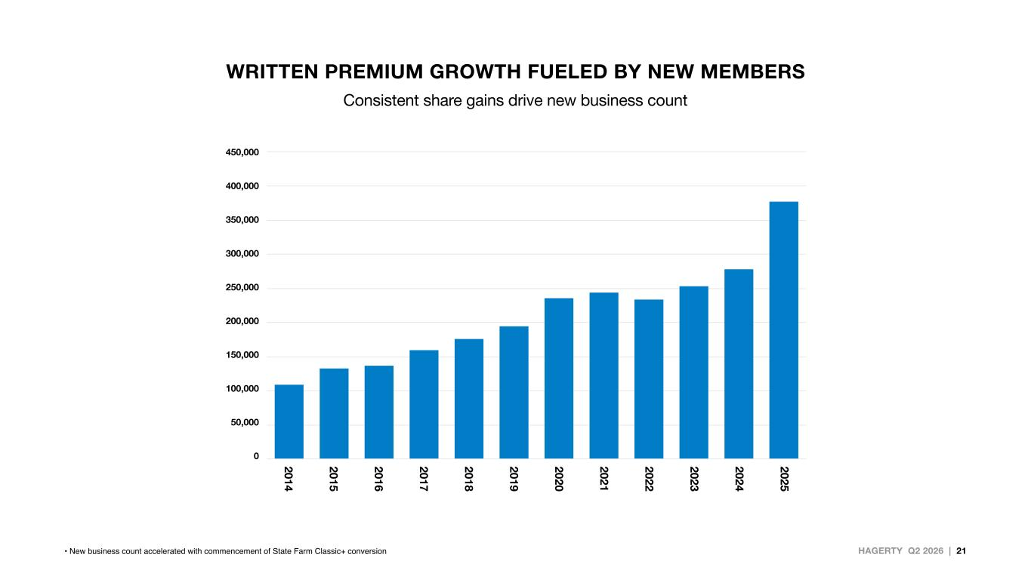
HAGERTY Q2 2026 | 21 450,000 400,000 350,000 300,000 250,000 200,000 150,000 100,000 50,000 0 2025 2024 2023 2022 2021 2020 2019 2018 2017 2016 2015 2014 • New business count accelerated with commencement of State Farm Classic+ conversion WRITTEN PREMIUM GROWTH FUELED BY NEW MEMBERS Consistent share gains drive new business count



